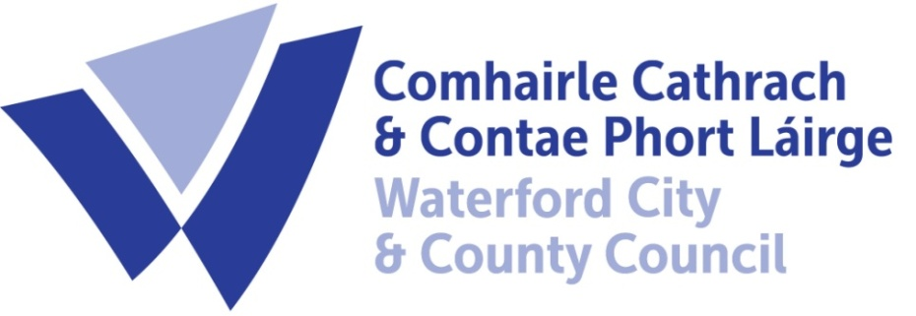
WATERFORD CITY AND COUNTY
Car Park Charges 2022
www.Waterfordeparking.ie QR code on the side of the parking meter

Car Park | Pay Parking Periods | Charges
Bolton Street  Waterford City | Monday to Saturday 8.30 am to 6.30pm  Sunday/Public Holiday | €1.00 per hour, minimum .50 cent, no maximum  FREE all day
Millers Marsh, Johnstown  Waterford City | Monday to Saturday  8.30 am to 6.30 pm  Sunday/Public Holiday | €1.00 per hour, €3.60 all day, minimum .50 cent,  FREE all day
Jenkins Lane  Waterford City | Monday to Thursday and Saturday 8.30 am to 6.30 pm  Friday 8.30am to 9.30pm  Sunday/Public Holiday | €1.80 per hour, €5.40 max 3 hours, Minimum .30 cent  FREE all day
Waterside  Waterford City | Monday to Saturday 8.30 am to 6.30pm  Sunday/Public Holiday | €1.00 per hour, €3.60 daily rate. Maximum .50 cent  FREE all day
Scanlons Yard, Causeway Dungarvan | Monday to Saturday  9.00 am to 4.30 pm  Sunday/Public Holiday | First 90 minutes free (free ticket must be displayed)  €1.10 per hour for first 2 hours and €3.30 for 24 hour ticket (plus free 90 minutes) €15 weekly ticket  FREE all day
Glanbia, Dungarvan | Monday to Saturday  9.00 am to 4.30 pm  Sunday/Public Holiday | First 30 minutes free (free ticket must be displayed) €1.10 per hour thereafter. Minimum .30 cent  FREE all day
The Burrows, The Prom, & On Street parking Tramore | 1st June – 30th September Monday to Sunday  10.00 am to 8.00 pm | 50 cent per hour or €2 per day

