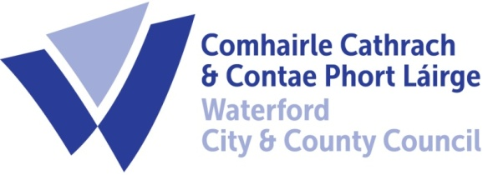

3rd February, 2021

To Each Member of the SPC for Environment, Climate Action and Biodiversity

A Chara,

A meeting of the above Strategic Policy Committee (S.P.C.) will be held on Tuesday, 16th February, 2021 at 2:30 p.m. and will be online. You are requested to attend.

AGENDA

- Minutes of last meeting 15th December 2020 for approval. (Attached)

- Matters arising.
- Discussion on Notice of Motion from Tom Hogan deferred from last meeting
In light of the climate crisis and the necessity of meeting our emissions obligations the importance of Transport policy is paramount.
The Environment, Biodiversity and Climate Action, SPC, recommends that WCCC along with other stakeholders undertake an immediate feasibility study of upgrades on the entire Wexford-Waterford-Limerick Corridor.
- Seek a guarantee from the Government that any Greenway developments will keep Rosslare/Wexford-Waterford as a valid railway.
- Establishment of an Iarnrod Eireann Regional Office - to manage & improve non-radial inner-city lines.
- A commitment to encourage modal transport shift across the region to rail for primary -commuting journeys.

- Draft Litter Management Plan – Report on Public Consultation

- Dog Fouling Compaign

- Issues from SPC Members
- Councillor Susan Gallagher
- Investigating the use of alternatives to glyphosate in public areas.
- Introducing a reduced mowing regime and implementing more pollinator-friendly planting in public areas.

- Schedule of meetings 2021

- CARO Climate Action Video – Local Actions

- A.O.B.

Fergus Galvin
Director of Services
Roads, Water & Environment

