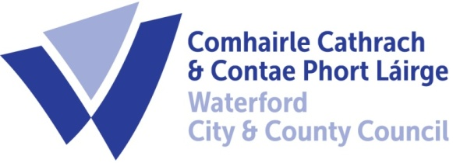

26th March , 2021
To Each Member of the SPC for Housing, Community, Libraries & Culture

A Chara,

A meeting of the above Strategic Policy Committee (S.P.C.) will be held on 30th March ,2021 at 12.30 p.m and will be online. You are requested to attend.

AGENDA

- Minutes of last meeting (23rd February, 2021 ) for approval. (Attached)

- Matters arising/updated

- Housing: Update from Vacant Homes Group

- Housing: Identifying LTL properties on CBL

- Housing: Changes to Housing Application Form and Areas of Choice

- Community: Update on Community Grants 2021

- Library/Culture: A discussion on Festival Funding Policy

- Library/Culture: Update from the Expansion of Library services sub-group

- Library/Culture: Update from “Walk of Fame” sub-group

- Issues from SPC Members

- A.O.B.

- Date of next meeting - 27th April 2021

Chair : Cllr Adam Wyse

Director of Services: Ivan Grimes
Housing, Community & Emergency Services

