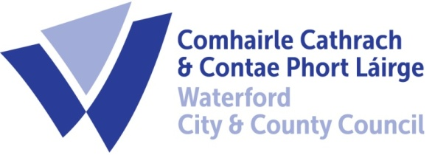

3rd February, 2021

To Each Member of the SPC for Transportation & Infrastructure

A meeting of the above S.P.C. will be held on Wednesday next, 3rd February, 2021 at 3.00 p.m. and will be online. You are requested to attend.

AGENDA

- Minutes of last meeting (Attached)

- Matters arising/update

- Beach Bye-laws (Attached)

- Campervan Bye-Laws (Attached)

- Harbour Bye-Laws (Attached)

Issues from PPN:
- Update on the traffic/cycle flow plans for Hennessey’s Road and the crossing on Barrack Street;
- Update and time frame on the Metropolitan Transport Strategy and Cycle Network Plan
- Mobility planning around schools – a trial
- PPN - request an additional representative on the SPC
- Other groups - Presentations to the SPC

- Date of next meeting

- A.O.B.

Fergus Galvin,
Director of Services,
Roads, Water and Environment.

