

NOISE ACTION PLAN
2019 - 2023
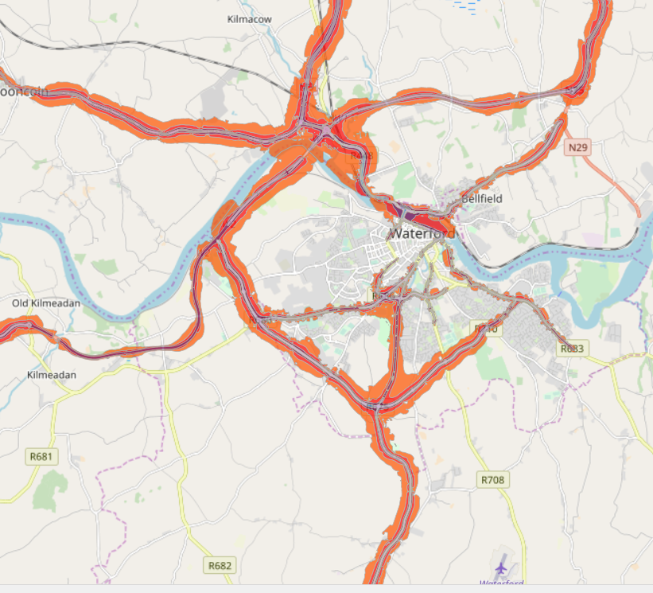
Contents
Executive Summary 5
1. Background Information/ Introduction 7
1.1 Purpose and Scope of END (Environmental Noise Directive) 7
1.1.1 The Aim of the Directive: 7
1.2 Purpose and Scope of the Regulations 7
1.3 Roles and Responsibilities 8
1.3.1 Noise Mapping Bodies 8
1.3.2 Action Planning Authorities 9
1.4 Key Phases 10
1.4.1 Identification of Areas required to be mapped 10
1.4.2 Preparation of Strategic Noise Maps 10
1.4.3 Development of the Noise Action Plans 11
1.4.4 Implementation of the Plans 12
2. Existing noise management legislation and guidance 13
2.1 National and Local Legislation or Guidance 13
2.1.1 Noise Action Plan Policy Statement: 13
Environmental Protection Agency Act 1992 13
2.1.2 Building Regulations 1997 (as amended) 14
2.1.3 Department of the Environment, Heritage and Local Government 14
2.1.4 National Roads Authority Guidelines 15
2.1.5 IPPC/ Waste Licensing 15
2.1.6 Wind Energy Planning Guidelines 16
2.1.7 Quarries and Ancillary Activities 16
2.1.8 National Planning Framework (Policy Objective 65); 17
2.1.9 Regional Spatial and Economic Strategy for the Southern Region 17
2.1.10 National and Local Planning Guidance 18
2.2 Other relevant noise management guidance 18
2.2.1 Professional Practice Guidance on Planning & Noise (ProPG) 18
3. DESCRIPTION OF THE ACTION PLANNING AREA 19
3.1 Extent of the Area 19
3.2 Description of the location and general population 19
3.3 Location of Noise Sensitive Groups 19
4. THE RESPONSIBLE AUTHORITY FOR ACTION PLANNING 20
4.1 Name and Contact Details for the Responsible Authority 20
4.2 Description of Other Bodies of Relevance 20
5. REVIEW OF NOISE ACTION PLANS 2008-2013. 21
6. SUMMARY OF THE RESULTS OF THE NOISE MAPPING 24
6.1 Overview of the Preparation of the Noise Maps 24
6.2 Data Sources Used to Compute the Various Noise Levels 24
6.3 Information on CRTN 25
6.4 General Guidance used to prepare the maps 26
6.5 Presentation of Results 26
6.6 Limitations of Maps/Results 28
7. IDENTIFICATION OF AREAS TO BE SUBJECTED TO NOISE MANAGEMENT ACTIVITIES 29
7.1 Assessing and prioritising actions. 29
7.2 Preservation of noise levels in quiet areas and noise sensitive locations 32
8. MITIGATION AND PROTECTION MEASURES 34
8.1 Management of Areas above Onset of Assessment Criteria 34
8.2 Description of How Areas Below the Thresholds will be Preserved 34
8.3 Discuss Any Known Future Developments Within the Action Planning Area and Describe how Noise Impact from these Areas will be Managed 34
8.4 Describe How the Extent of Noise Impact will be confirmed 34
8.5 Review of Possible Mitigation Measures 34
8.6 Possible Mitigation Measures 35
8.6.1 Abatement Measures 35
8.6.2 Changing road surfaces 35
8.6.3 Screening noise 36
8.6.4 Soundproof Glazing 36
8.7 Measures to prevent noise and reduce, avoid or relocate the various types of noise source 36
9. Public Participation 39
9.1 Overview 39
9.4 Notification of Plan 40
10. Implementation Plan 41
10.1 Roles and Responsibilities 41
10.2 Targets and Objectives 41
10.3 Programme of Works 41
10.4 Evaluation, Review and Corrective Action Program 42
11. Summary and Conclusions 43
APPENDIX 1: Definitions & Explanations 45
APPENDIX 2: Public Consultation 46
APPENDIX 3: Lden (dB) levels Waterford City and County 47
APPENDIX 4: Lnight (dB) levels Waterford City and County 48
APPENDIX 5: Buildings with score >17 identified for further assessment (location maps) 49
APPENDIX 6: Buildings with score >17 identified for further assessment (data table with coordinates) 56

Executive Summary

This Noise Action Plan is aimed at managing Environmental Noise, as required by the EU Directive 2002/49/EC relating to The Assessment and Management of Environmental Noise (known as the ‘END’) which was transposed by the Environmental Noise Regulations 2018, SI number 549/2018. The aim of the Directive is ‘to define a common approach intended to avoid, prevent or reduce on a prioritised basis the harmful effects, including annoyance, due to exposure to environmental noise’.

The END requires member States to produce strategic noise maps for the main sources of environmental noise i.e. major roads, major railways, etc.

The Environmental Noise Regulations 2018, SI number 549/2018 provide for a two-stage approach to the assessment and management of environmental noise. Firstly, strategic noise maps must be prepared for areas and infrastructure falling within defined criteria, e.g. major roads, railways and airports. Secondly, the Regulations require the preparation of noise action plans for each area concerned, based on the results of the mapping process. The fundamental objective of action plans is the prevention and reduction of environmental noise where necessary.
Noise Action Plans are required to be produced by the Action Planning Authorities in 2018. These Action Planning Authorities are those local authorities within whose functional areas major roads, etc are located. Under the Environmental Noise Regulations 2018, SI number 549/2018 Waterford City and County Councils are the designated body for preparing a Noise Action Plan for roads within the city and county that have traffic levels of more than 3 million vehicles per year. This applied to certain stretches of the N25, the R448 (Sallypark Road), R675 (Tramore Road), R680 (Cork Road), R683 (Dunmore Road), R686 (Bridge Street and Ashe Road), R709 (Inner Ring Road), R710 (Outer Ring Road) and the R711 (New Ross Road).

This plan provides a description of the extent of the action planning area and the stretches of road affected by environmental noise. The results of the noise mapping indicate that a relatively small number of the population within the functional area of Waterford City and County Councils are being exposed to noise levels due to major road traffic sources.

Using GIS tools a Decision making Matrix A was applied to TIIs final building’s results dataset used for the exposure assessment. The locations where clusters or single dwellings exceeded the threshold of 17 were identified for further noise assessment.

Background Information/ Introduction

1.1 Purpose and Scope of END (Environmental Noise Directive)
In 2002 the European Union issued Directive (2002/49/EC) relating to the assessment and management of environmental noise. This Directive is referred to as the Environmental Noise Directive or END.

1.1.1 The Aim of the Directive:
“to define a common approach intended to avoid, prevent or reduce on a prioritised basis the harmful effects, including annoyance, due to exposure to environmental noise”
The key requirements of the END can be set out in three stages as follows:
      - Undertake strategic noise mapping to determine exposure to environmental noise.
      - Ensure information on environmental noise and its effects are made available to the public.
      - Adopt action plans, based upon the noise-mapping results, with the objective of reducing and preventing environmental noise where necessary and to preserving environmental noise quality where it is good.

1.2 Purpose and Scope of the Regulations
Statutory Instrument No. 549/2018, also known as the Environmental Noise Regulations, gives effect to European Council Directive 2002/49/EC.
The Regulations set out to:
“Provide an implementation in Ireland of a common approach within the European Community intended to avoid, prevent or reduce on a prioritised basis the harmful effects, including annoyance, due to exposure to environmental noise.” - Article 4(1)

The Regulations are to apply to environmental noise to which people are exposed, in particular in built up areas, in public parks or other quiet areas in an agglomeration, in quiet areas in open country, near schools, near hospitals and near other noise sensitive buildings and areas. – Article 4(2)

In the context of the Regulations, environmental noise is defined as unwanted or harmful outdoor sound created by human activities, including noise emitted by means of transport, road traffic, rail traffic, air traffic, and from sites of industrial activity. – Article 2(1)

The Regulations shall not apply to noise caused by an exposed person, noise from domestic activities, noise created by neighbours, noise at work places, noise inside means of transport, or noise due to military activities in military areas. – Article 4(3)

Roles and Responsibilities
The Regulations designate the Environmental Protection Agency (EPA) as the national authority charged with overseeing the implementation of the Regulations – Article 5(1). As the designated national authority, it is the responsibility of the EPA to report the results of the strategic noise mapping and action planning to the Commission. - Article 5(4). The EPA is also required to provide advice and guidance to the relevant noise mapping bodies and action planning authorities.

Noise Mapping Bodies
The relevant noise mapping bodies were required to produce strategic noise maps for the main sources of environmental noise by June 2017, in respect of the calendar year 2016, for:
- Any agglomeration with a population greater than 100,000
- Any major road with more than 3 million vehicle passages per year
- Any major railway with more than 30,000 train passengers per year
- Any major airport with more than 50,000 movements per year

Under the Regulations the following organisations have been designated as noise mapping bodies:
- For the agglomeration of Cork, Cork City and Cork County Councils.
- For the agglomeration of Dublin, the four Dublin local authorities
- For major railways, Iarnród Éireann or the Railway Procurement Agency-now part of TII, as appropriate
- For major roads, the Transport Infrastructure Ireland (TII) for national roads and the relevant road authority or authorities, as appropriate for non-national roads.
- For major airports, the relevant airport authority.

Action Planning Authorities
Action Planning Authorities are responsible for making Action Plans following consultation with the EPA and the relevant noise mapping bodies. Action Plans must satisfy the minimum requirements as set out in the Fourth Schedule of the Regulations.
Action Planning Authorities produced Action Plans for the first and second round during 2008 and 2013. This action plan is being produced for the third round starting in 2018. This will be carried out every five years thereafter. Action Plans must be produced based on the results of the noise mapping. It is also required to review and revise the noise maps if necessary, from time to time and whenever a major development occurs affecting the existing noise situation.
The Regulations require the Action Planning Authorities to consult the public when drawing up and revising Action Plans. – Article 12(5)
Under the Regulations (Art.7) the following organisations have been designated as action planning authorities:
• For the agglomeration of Cork, Cork City and Cork County Councils.
• For the agglomeration of Dublin, the four Dublin local authorities
• For major railways, the local authority or local authorities within whose functional area or areas the railway is located.
• For major roads, the local authority or local authorities within whose functional area or areas the road is located.
• For major airports, the local authority or local authorities within whose functional area or areas the airport is located.
The EPA advise that Article 7 of the Regulations should be interpreted to mean “any local authority or local authorities within whose functional area or areas are affected by noise from the (road or railway or airport)” (Ref. EPA Guidance Notes)

Key Phases
The key phases in meeting the requirements are as set out below.

Identification of Areas required to be mapped
The Action Plan must refer to places near the major roads, major railways and major airports, and within any relevant agglomeration which means those places affected by noise from the major sources, as shown by the results of the noise mapping, and all locations within any relevant agglomeration. The EPA advise that noise from major sources is regarded as affecting an area if it causes either an Lden value of 55dB(A) or greater or an Lnight of 50dB(A) or greater anywhere within an area. (Ref. EPA Guidance Notes for Noise Action Planning 2009).

In the case of City and County Waterford major noise sources meeting the criteria set out in the Regulations are those roads with more than 3 million vehicle passages per year. Areas which were required to be mapped are in the vicinity of these roads.

Preparation of Strategic Noise Maps
Article 6 of Statutory Instrument No. 140 of 2006 outlines the relevant noise mapping bodies and for major roads these are:-
(i) Where such roads are classified as national roads in accordance with Section 10 of the Roads Act 1993 (No. 14 of 1993), the TII on behalf of the action planning authority or authorities concerned, and
(ii) Other than those provided for in sub-paragraph (i), the relevant road authority or authorities, as appropriate.
Strategic noise mapping was undertaken during 2016/17 by TII in respect of the national and regional roads in County Waterford. Data from the Transport Infrastructure Ireland (TII) traffic counting system was used to identify those roads which met the 3 million vehicle passages per year criterion. Data from the local authority was used to identify the regional roads which met the 3 million vehicle passages per year criterion.

Noise mapping uses software that estimates the noise level in an area from a particular noise source. The objective is to identify locations where action may be needed to reduce high noise levels and to protect areas where the noise levels are low.

The strategic noise maps generated by the Transport Infrastructure Ireland (TII) give predictions for two noise indicators, Lden and Lnight. The Lden maps are presented in 5dB contour bands beginning at 55dB Lden and ranging up to 75dB Lden. These maps also give an indication of noise levels that are predicted greater than 75dB Lden. Lnight maps range from 45dB to greater than 70dB Lnight. The noise levels indicated are attributed only to the specific source of noise being considered, namely the traffic on the roadway and therefore do not consider any other noise source.

Waterford City and County Council were required to produce maps for all major non-national roads with a traffic flow above 3 million vehicle passages per annum. This applied to certain stretches of the N25, the R448 (Sallypark Road), R675 (Tramore Road), R680 (Cork Road), R683 (Dunmore Road), R686 (Bridge Street and Ashe Road), R709 (Inner Ring Road), R710 (Outer Ring Road) and the R711 (New Ross Road).

Development of the Noise Action Plans
Within the framework of the Environmental Noise Directive (END) and the context of sustainable development, the overall aim of managing environmental noise is to avoid, prevent and reduce the harmful effects due to long term exposure to environmental noise, which would in turn promote good health and a good quality of life.
The emphasis of the END and the Regulations is on “important” areas as established by the strategic maps. The Action Plan is therefore designed with the twin aims of;
• Avoiding significant adverse health impacts from noise and
• Preserving environmental noise quality where it is good.

The Regulations require the Action Planning Authority to consult the public when drawing up and revising Action Plans – Article 11(6). To comply with this requirement a formal public consultation exercise on the Draft Action Plan will be undertaken. The public consultation process will have regard to the Department of Public Expenditure and Reform publication Consultation Principles & Guidelines 2016.

Relevant bodies will also be proactively consulted in parallel to the wider public consultation.

The methodology for the public participation will ensure that the public was consulted about proposals and given early and effective opportunities to participate in the preparation of the Action Plans. The results of the public participation will be taken into account and the public informed of the decisions taken. Sufficient time will be allowed for each stage of public participation process.

Implementation of the Plans
Plans are to be implemented within a five-year time scale. The Regulations require action planning authorities to review (and revise, if necessary) the Noise Action Plan every five years, or sooner where a material change in environmental noise in the area occurs. (Article 12 (1)).

Existing noise management legislation and guidance

2.1 National and Local Legislation or Guidance
All proposals for development/works under the Action Plan will be required to demonstrate compliance with the requirements of environmental and planning legislation and planning and licensing processes, including existing provisions of relevant land use plan(s) and policy documents such as the National Planning Framework –National policy objective 65, Regional Spatial and Economic Strategy for the Southern Region, the Waterford City Development Plan 2013-2019, the Dungarvan Town Development plan 2012-2018 and Waterford County Development Plan 2011-2017.

2.1.1 Noise Action Plan Policy Statement:
The aim of Waterford City and County Council is to use the EPA Act 1992 were possible in order to take steps to limit environmental noise. In addition to this the council will require developers for any future developments which are located beside the identified major routes to take cognisance of the noise action plan

Environmental Protection Agency Act 1992
The existing statutory provisions have come about on foot of the Environmental Protection Agency Act of 1992. Sections 106 to 108 of the Act of direct relevance, and may be summarised as follows:
• Section 106 gives the relevant Minister certain powers to regulate noise that may give rise to a nuisance or be harmful to health or property.
• Section 107 gives powers to local authorities and the EPA to serve notice to take steps to control noise.
• Section 108 sets out a process whereby noise issues may be taken to the District Court, which may make an order requiring that the person or body responsible for the noise takes steps to eliminate or ameliorate the noise in question.

2.1.2 Building Regulations 1997 (as amended)
Part E of the Building Regulations (Part E Amendment) Regulations 2014 relates to the mitigation of sound transfer between dwellings and rooms within a building
Sound. E1 Each wall and floor separating a dwelling from— (a)
another dwelling or dwellings, (b) other parts of the same building, (c) adjoining buildings, shall be designed and constructed in such a way so as to provide reasonable resistance to sound.
Reverberation. E2 The common internal part of a building which provides direct access to a dwelling shall be designed and constructed so as to limit reverberation in the common part to a reasonable level.

Definitions for this Part.E3 In this Part—“Reverberation” means the
persistence of sound in a space after a sound source has been stopped.”

No consideration is given to the nature or location of the building or potential noise sources. More comprehensive regulations should include façade noise insulation guidelines and appropriate standards to be met before habitation.

2.1.3 Department of the Environment, Heritage and Local Government
The DEHLG has published the following documents relating to sustainable development in the urban environment:

• Sustainable Urban Housing: Design Standards for New Apartments (Guidelines for Planning Authorities), September 2007.
• Sustainable Residential Development in Urban Areas: Guidelines for Planning Authorities May 2009
• Urban Design Manual: A best practice guide, May 2009

The document dealing with Design Standards for New Apartments calls for “attention at the design and construction stages to prevent undue noise transmission between units”.
The guidelines for Sustainable Residential Development highlight the need to “Deliver a quality of life which residents and visitors are entitled to expect, in terms of amenity, safety and convenience” and states that “Privacy is an important element of residential amenity”.

The Urban Design Manual lists Privacy and Amenity as one of twelve key issues, with specific reference to the need to prevent sound transmission in homes by way of appropriate acoustic insulation or layout. There is some comment in relation to the use of appropriate building materials and also the zoning of dwellings to minimise the potential for excessive noise transfer.

2.1.4 National Roads Authority Guidelines
The National Roads Authority (NRA) (now Transport Infrastructure Ireland TII) has published the document “Guidelines for the Treatment of Noise and Vibration in National Road Schemes” 2004, and “Good Practice Guidance for the Treatment of Noise during the Planning of National Road Schemes” 2014, which sets out the procedure to be followed in respect of the planning and design of national road schemes. These guidelines specify design goals for noise associated with the construction and operation of new national road schemes.

The TII Guidelines for the design of new national roads indicates that mitigation measures should be considered above a level of 60dB Lden free-field. The guidelines put forward measures for mitigating the adverse effects of road construction in so far as possible through the use of measures such as alignment changes, barrier construction, and the use of low noise road surfaces.

2.1.5 IPPC/ Waste Licensing
Certain activities that are required to be licensed may be subject to noise conditions. The relevant guidance is set out in the EPA publication “Guidance Note for Noise: Licence Applications, Surveys and Assessments in Relation to Scheduled Activities (NG4)” This document contains suggested the following noise limits
Scenario | Daytime Noise  Criterion , db LarT (7:00 to 19:00 hrs) | Evening Noise  Criterion , db LarT (19:00 to 23:00 hrs) | Daytime Noise  Criterion , db LarT (23:00 to 07:00 hrs)
Quiet Area | Noise from the licenced site to be at least 10dB below the average daytime background noise level measured during the baseline survey. | Noise from the licenced site to be at least 10dB below the average evening background noise level measured during the baseline survey. | Noise from the licenced site to be at least 10dB below the average night time background noise level measured during the baseline survey.
Areas of Low  background noise | 45dB | 40dB | 35dB
All other areas | 55dB | 50dB | 45dB
Table 1 NG4; Guidance Note for Noise Licence Applications

2.1.6 Wind Energy Planning Guidelines
This is a DEHLG document dealing specifically with wind energy developments. Noise levels from wind farms are generally expressed in terms of the L₉₀ indicator. The document suggests a “lower fixed limit of 45dB(A) or a maximum increase of 5dB(A) above background noise at nearby noise sensitive locations”.
The latter requirement may be relaxed in areas with low background levels. A fixed limit of 43dB(A) at night time is deemed appropriate as there is no requirement to protect external amenity.
To note these guidelines are under review at present.

2.1.7 Quarries and Ancillary Activities
Quarries and Ancillary Activities, Guidelines for Planning Authorities, published in April 2004 by Department of the Environment, Heritage and Local Government contains a discussion of the primary sources of noise associated with quarrying and offers guidance in relation to the correct approach to be followed in respect of assessment and mitigation.

Suggested noise limit values are 55dB L_{Aeq,1hr} and 45dB L_{Aeq,15min} for daytime and night time respectively, although more onerous values may be appropriate in areas with low levels of pre-existing background noise. In respect of blasting, reference is made to EPA guidance to the effect that “blasting should not give rise to air overpressure values at the nearest occupied dwelling in excess of 125dB (Lin) max. peak with a 95% confidence limit”.

The guidance or limits which do exist only cover a restricted number of the possible situations where community or environmental noise is an issue to be addressed. Consequently, there are many situations for which there are currently no direct guidelines or legislation. This can lead to inconsistencies in carrying out noise assessments and to existing measures being quoted out of context.

2.1.8 National Planning Framework (Policy Objective 65);
In 2017, the Department of Housing Planning and Local Government (DHPLG) issued the National Planning Framework 2040 which includes- policy objective 65:
“Promote the pro-active management of noise where it would have significant adverse impacts on health and quality of life and support the aims of the Environmental Noise Regulations through National planning guidance and Noise Action plans”.
The National Plan will be considered in the development of the Noise Action Plan. National and regional transport initiatives that may arise from implementation of the National Planning Framework (NPF) and the Regional Spatial and Economic Strategy (RSES) for the Eastern and Midlands Region (currently in preparation, see Section 2.1.9 below) and have the potential to result in: adverse health effects that will need to be mitigated; and/or beneficial effects with regard to preserving environmental noise quality. Such issues will be considered during the implementation of the NPF and RSES, including as part of the environmental assessments, where required, for individual transport initiatives.

2.1.9 Regional Spatial and Economic Strategy for the Southern Region
The Regional Spatial Strategy is currently being finalised. This is being developed from the National Planning Framework.

2.1.10 National and Local Planning Guidance
While there is no national guidance or policy to address the issue of noise during the planning process, Local Authorities have the power to set such conditions during the planning process. Waterford City Council's Development Plan 2013 – 2019 makes reference to environmental noise, and requires developers seeking planning which would result in sensitive receptors being exposed to noise in breach of the Waterford County Council's Development Plan 2011 – 2017 makes reference to the Environmental Noise Regulations, but does not propose any action.

2.2 Other relevant noise management guidance

2.2.1 Professional Practice Guidance on Planning & Noise (ProPG)
The ProPG for new residential developments was published in May 2017 by the Association and Noise Consultants (ANC), Chartered Institute of Environmental Health and UK Institute of Acoustics. It’s primary goal is to provide assistance in planning to deliver sustainable development by promoting good health and well-being in relation to noise. It encourages the use of good acoustic design process in and around proposed new residential development, having regard to national policy. Any issues related to noise should be given consideration at the earliest stages of the development process in order to facilitate streamlined decision making in planning.

The ProPG follows a systematic, proportionate, risk based, two-stage, approach. Stage One is an Initial Site Noise Risk Assessment which should be conducted to establish the level of risk from noise, not including any mitigation measures.
Stage Two is a full noise assessment including four recommended key elements:
- Element 1 - demonstrating a “Good Acoustic Design Process” avoiding “unreasonable” and preventing “unacceptable” acoustic conditions;
- Element 2 - observing “Internal Noise Level Guidelines”;
- Element 3 - undertaking an “External Amenity Area Noise Assessment”;
- Element 4 - consideration of “Other Relevant Issues”.
To support proposals for a development an Acoustic Design Statement should
be produced which will aid recommendations formulated by the decision maker.

DESCRIPTION OF THE ACTION PLANNING AREA

3.1 Extent of the Area
Certain stretches of the N25, the R448 (Sallypark Road), R675 (Tramore Road), R680 (Cork Road), R683 (Dunmore Road), R686 (Bridge Street and Ashe Road), R709 (Inner Ring Road), R710 (Outer Ring Road) and the R711 (New Ross Road) within the city and county boundaries have traffic volumes of over 3 million vehicles per year. The railway in Waterford falls under the threshold for inclusion in the noise action planning and so is not included in this plan.

3.2 Description of the location and general population
County Waterford lies in the south east of Ireland and is populated by 116,176 (City: 53,504) people. According to the 2016 Census, there are 47,297 private households in the entire county, (City: 20,009, County area: 27,288), with an average of 2.5 occupants per dwelling.
The majority of the population of County Waterford lies in the east of the county in the vicinity of Waterford City and Tramore.

3.3 Location of Noise Sensitive Groups
The Action Planning Authority shall determine the number of noise sensitive premises that lie within the various noise contours bands generated by the strategic noise mapping. Housing, hospitals and schools are generally regarded as noise sensitive premises. The APA may further opt to include other premises or specific land types for inclusion as noise sensitive premises depending on local circumstances. These areas could include public spaces, open spaces, places of worship, nursing homes, childcare facilities, office and some livestock farms.

The identification of individual premises shall be carried out during the first phase of the implementation of the Noise Action Plan.

THE RESPONSIBLE AUTHORITY FOR ACTION PLANNING

4.1 Name and Contact Details for the Responsible Authority
Waterford City and County Councils are the Action Planning Authorities responsible for the preparation of this Noise Action Plan. Any queries relating to this plan can be forwarded to the following address:
Transportation Section,
Waterford City and County Council,
Menapia Building,
The Mall
Waterford.
Email: bstosic@waterfordcouncil.ie

4.2 Description of Other Bodies of Relevance
The Environmental Protection Agency (EPA) is the designated national authority responsible for overseeing the implementation of the Regulations. The EPA is required to provide advice and guidance to the relevant noise mapping bodies and action planning authorities and is responsible for reporting information to the European Commission.

The Transport Infrastructure Ireland (TII) is the designated noise mapping body acting on behalf of the action planning authorities for major roads where such roads are classified as national roads.

Both the EPA and the TII will be consulted in relation to the Action Plan.

REVIEW OF NOISE ACTION PLANS 2008-2013.

The first round of noise action plans were produced for roads with over 6 million vehicle passages per annum in 2008, as such the quantum of roads which fell into this category was much less than in 2013.

As such Waterford County Council was not required to produce a Noise Action plan in the first round.

Waterford City did produce a noise action plan for the period 2008 - 2013. In this action plan it identified 607 residences representing 894 people with an L_{night} exposure of greater than 60dB, and 1272 residences or 1968 people with an L_{den} exposure greater than 65dB.

The actions proposed by Waterford City Council in the 2008-2013 action plan included:
- Reduction of number of HGVs through city centre ;
- Promoting public transport, including the Green Routes;
- Traffic management ;
- Promoting and encouraging environmentally friendly means of transport, e.g. walking and cycling;
- Improving traffic flows e.g. through the implementation of the Green Routes.

HGV Management Strategy - '5 axle ban'
Waterford City and County Council have introduced a '5 axle ban' on certain streets in Waterford City in order to reduce the usage of these vehicles in the city and to encourage through traffic to utilise other available routes (Waterford Bypass)

The restriction applies to vehicles of greater of 5 axles, i.e. Articulated Trucks, and from 11.00am until 7pm. The cordon implemented was selected to prevent through traffic coming through the city, while also minimising the area affected, to reduce the burden on business in the city.

In Dungarvan from 1st September 2018 the 5 Axle Ban was introduced to prohibit heavy good vehicle with 5 or more axles from entering the town centre . A permit system is operated to allow vehicles enter the cordon in exceptional circumstances where necessary.

Special Speed Limit Bye-Laws 2017
A countywide review of speed limits was carried out in accordance with the guidelines issued by the Department of Transport Tourism and Sport for the application of speed limits in Ireland. The process included an extensive pre-draft consultation with the TII, An Garda Siochána, local interest groups, adjoining local authorities and District Councils. Following this process, the draft bye-laws were advertised for public consultation from 22nd February to 23rd March 2017, both online and in our Customer Services Departments.

Submissions received were considered by each of the District Councils at workshops during March/April 2017 and their recommendations were put to the Plenary Council meeting in April for approval and adoption.

The Special Speed Limit Bye-Laws 2017 came into force on Friday 2nd June, 2017. For the first time a special speed limit of 30km/h has been introduced in all housing estates in charge by the Council throughout the county. Signage to reflect changes in speed limits was installed by the Council during first 3 months of the legislation.

Walking and Cycling
Dungarvan is a 'Smarter Travel' town, which means we are trying to promote the safe use of cycling as part of a campaign to move people away from relying on cars as their only method of transport. Cycling around Dungarvan has never been safer and easier with cycle paths.

In Waterford City there is the Safe Cycling programme for schools, to encourage good habits in school-age people.

Public Transport
In December 2018, Bus Éireann, in conjunction with the National Transport Authority (NTA) upgraded bus service in Waterford city with new timetables extended hours of operation and increased service frequency. For the first time in the city there is also a full Sunday schedule.
Since December there has been significant increase in public bus usage in the city.

Traffic management-traffic lights optimization
Waterford traffic lights system is operated by SCATS Sydney Coordinated Adaptive Traffic System. This system makes use of traffic cameras and induction loops installed within road pavement to count vehicles at each intersection and adopts the timing of traffic signals in the networks through a centralized datacenter. Waterford council is maintaining this system at a high level, making sure that the traffic lights are operating most efficiently, reducing the traffic congestion and noise pollution.

SUMMARY OF THE RESULTS OF THE NOISE MAPPING

6.1 Overview of the Preparation of the Noise Maps

Strategic noise mapping was undertaken during 2016/17 by Transport Infrastructure Ireland (TII) in respect of major roads in County Waterford. TII is the designated noise mapping body for national major roads. TII undertook noise mapping of non-national major roads on behalf of Waterford City and County Council.

A noise map is a graphical representation of the various noise levels in a particular area with different colours representing different noise levels in dB(A). To produce a noise map a number of variables must be determined in order to correctly represent the amount of noise generated at the source, e.g.. by traffic driving on the road. The noise level at the source for road traffic is primarily influenced by traffic speed, the overall quantity of vehicles in the traffic flow, the proportion of heavy commercial vehicles, (HCVs), in the flow and the type of road surface. The manner in which the noise propagates away from the source must then be calculated; this involves determining the reduction in noise level as it propagates from the source. Environmental noise from road traffic decreases as it propagates from the source by the following principal attenuation mechanisms: geometric divergence, atmospheric absorption, ground attenuation and attenuation by diffraction.

6.2 Data Sources Used to Compute the Various Noise Levels

Shapefiles representing each of the items presented in Table 2 below were assembled in ArcGIS

Road | Buildings | Contour | Topography | Walls | Embankments | Bridges
Direction | Height | Contour Height | Ground cover absorption | Height | Height | Start/End Point
Texture Depth | Height | Contour Height | Ground cover absorption | Reflection Properties | Height | Height
Lane Width/Road Width | Height | Contour Height | Ground cover absorption |  | Height
Surface Type | Height | Contour Height | Ground cover absorption |  | Height
Speed | Height | Contour Height | Ground cover absorption |  | Height
18-hour Traffic Flow | Height | Contour Height | Ground cover absorption |  | Height
Carriageway Type | Height | Contour Height | Ground cover absorption |  | Height
Composition | Height | Contour Height | Ground cover absorption |  | Height
Table 2: Required Attributes for each dataset

Where necessary Toolkits presented in the “Good Practice Guide for Strategic Noise Mapping and the Production of Associated Data on Noise Exposure”, developed by the European Commission Working Group Assessment of Exposure to Noise (WG-AEN), were used to collect some of the data required above.

6.3 Information on CRTN
The UK national computation method “Calculation of Road Traffic Noise (CRTN), Department of Transport – Welsh Office, HMSO, London, 1988” as recommended in Part II of the Second Schedule of the Environmental Noise Regulations 2006 (S.I. No. 140 of 2006), in place at the time of the strategic noise mapping, was used for all calculations. This method was released in 1988 and replaced the previous method which was developed in 1975.

The revision was carried out by the Transport and Road Research Laboratory and the Department of Transport in the United Kingdom. This publication includes a method which may be used to determine the noise source emission levels of road traffic due to the nature of its composition along with a method to determine how the noise is attenuated as it propagates away from the source. The method treats roads as line sources and predicted noise levels are expressed in terms of the L10 index, which is the noise level exceeded for 10% of the time, and is therefore quite different to the Lden indicator. As such, a conversion factor is required.

6.4 General Guidance used to prepare the maps
In order to determine the average speed at which vehicles were travelling, it was assumed that vehicles travelled at the sign posted speed limit for the road as suggested in Toolkit 3.5 in WG- AEN’s Good Practice Guide.

Walls/Embankments
A LiDar survey was used to identify acoustically significant features along identified roads as well as, as built drawings and existing NRA/TII databases.

Building Heights
Buildings were set to a standard height of 8m, representing an average 2-storey house with a 2m roof. This is the default height suggested in Toolkit 15.2 in WG-AEN’s Good Practice Guide which should be used when no information is available. Where feasible, larger buildings were represented more accurately.

Traffic Counts
CRTN requires 18-hour traffic counts to describe a road source. These were obtained by examining the diurnal profile for both HCV and Non-HCV traffic and calculated an 18-hour flow based on Annual Average Daily Traffic (AADT) figures.

6.5 Presentation of Results
Noise maps for major roads in County Waterford are presented in Appendix 3 and Appendix 4. The maps are prepared for Lden and Lnight and noise levels are presented in 5dB contour bands. The maps will also be available on the Waterford City and County Councils website.
L_{den} Results
L_{den}(db) | Approximate Number of People*
L_{den}(db) | Waterford County
55 -59 | 2,740
60-64 | 1,846
65-69 | 1,745
70-74 | 956
>75 | 106
The total number of people exposed is less than the total population, as some areas were too far remote from the major roads to be considered in this assessment
Table 3a: Approximate Number of People exposed to different Lden levels

L_{den}(db) | Approximate Area (km²)
L_{den}(db) | Waterford County
>55 | 43
>65 | 8
>75 | 0
Table 3b: Approximate Area exposed to different Lden levels

L_{den}(db) | Approximate Number of Dwellings
L_{den}(db) | Waterford County
>55 | 4,081
>65 | 1,709
>75 | 76
Table 3c: Approximate Number of Dwelings exposed to different Lden levels

L_{den}(db) | Approximate Number of People
L_{den}(db) | Waterford County
>55 | 7,394
>65 | 2,807
>75 | 106
Table 3d: Approximate Number of People exposed to different Lden levels

L_{night} Results

L_{night}(db) | Approximate Number of People*
L_{night}(db) | Waterford County
50 -54 | 2,146
55-59 | 1,812
60-64 | 1,136
65-69 | 106
>70 | 0
The total number of people exposed is less than the total population, as some areas were too far remote from the major roads to be considered in this assessment
Table 4a: Approximate Number of People exposed to different Lnight levels

L_{night}(db) | Approximate Area (km²)
L_{night}(db) | Waterford County
>50 | 23
>60 | 4
>70 | 0
Table 4b: Approximate Area exposed to different Lnight levels

L_{night}(db) | Approximate Number of Dwellings
L_{night}(db) | Waterford County
>50 | 2,960
>60 | 872
>70 | 0
Table 4c: Approximate Number of Dwellings exposed to different Lnight levels

L_{night}(db) | Approximate Number of People
L_{night}(db) | Waterford County
>50 | 5,200
>60 | 1,242
>70 | 0
Table 4d: Approximate Number of People exposed to different Lnight levels

The L_{den} noise contour maps and for Waterford City and County are shown in Appendix 3. The L_{night} contour maps are in Appendix 4.

6.6 Limitations of Maps/Results
Whilst the computer modelling may identify quiet areas or areas with undesirable high sound levels, this in itself may not indicate that priority action is required.

IDENTIFICATION OF AREAS TO BE SUBJECTED TO NOISE MANAGEMENT ACTIVITIES

This action plan encompasses the stretches of major roads on the N25, the R448 (Sallypark Road), R675 (Tramore Road), R680 (Cork Road), R683 (Dunmore Road), R686 (Bridge Street and Ashe Road), R709 (Inner Ring Road), R710 (Outer Ring Road) and the R711 (New Ross Road) within the city and county boundaries with over 3 million vehicle passages per year. Where required, the plan will address means of managing environmental noise from road traffic.

7.1 Assessing and prioritising actions.
There are no statutory limits in place in relation to environmental noise exposures at EU or national level. The EPA recommends (ref EPA Guidance document) that the proposed onset levels for assessment of noise mitigation measures for noise due to road traffic should be as follows:
- 70dB, Lden and
- 57dB, Lnight
Using these thresholds for Lden and the figures given in tables 3 & 4, it is estimated that there is a population of 1062 people who experience road traffic noise levels in excess of the assessment threshold.

Using threshold for Lnight and the figures in tables 3 & 4, it is estimated that there is a population exposure of 1607 people who experience road traffic noise levels in excess of the assessment threshold.

The proposed onset levels for assessment of noise level preservation for quiet areas, where the existing noise level is considered good are as follows:
- 55dB, Lden and
- 45dB, Lnight
In order to focus resources on areas in most need of improvement, a decision matrix will be applied, based on work carried out by Dublin Agglomeration (ref). The final matrix score is determined based on three variables:

1. The calculated environmental noise level (from the noise mapping data).
2. The type of location (e.g. town centre, commercial, residential).
3. The noise source (i.e. road, rail, airport, agglomeration).

1. Calculated environmental noise level:
The score under this variable is assigned based on the calculated Lden and Lnight levels for the location.

2. Type of location:
This score is assigned based on the type of land use in the area and on the receptor. A higher score is assigned to open countryside on the basis of the expectation that residences in open countryside will have lower ambient noise levels than commercial areas and town centres. A higher score is also assigned to noise sensitive locations because of the requirement for low noise levels for them to function effectively (e.g. schools, churches, funeral homes, hospitals, nursing homes).

3. Noise Source:
In Waterford, the noise source is the same for all assessments (i.e. noise from major roads).

Data obtained from the matrix tool will enable Waterford Council to prioritise actions. A matrix assessment score of 17 or greater will be taken to indicate that the threshold levels may have been exceeded and that the location should be included in the shortlist for further assessment.

The table for Decision Support Matrix A is shown on the next page and the method to be applied by Waterford Council to identify and prioritise noisy areas.

 | Decision Matrix
 | Location:
Decision Selection Criteria |  | Score Range Lden | Score Range Lnight | SubTotal
 | <45 | 5 | 6
Noise Band(dB(A)) | 45-49 | 4 | 5
Noise Band(dB(A)) | 50 - 54 | 3 | 4
Noise Band(dB(A)) | 55 - 59 | 2 | 2
Noise Band(dB(A)) | 60-64 | 1 | 3
Noise Band(dB(A)) | 65-69 | 2 | 4
Noise Band(dB(A)) | 70-74 | 3 | 5
Noise Band(dB(A)) | 75-79 | 4 | 7
Noise Band(dB(A)) | >=80 | 5 | 7
Type of Location | City Centre | 1 | 1
Type of Location | Commerical | 1 | 2
Type of Location | Residential | 2 | 3
Type of Location | Noise Sensitive Location | 3 | 3
Type of Location | Quiet Area | 3 | 3
Type of Location | Recreational Open Space | 2 | 2
Type of Noise source | Air | 3 | 4
Type of Noise source | industry | 2 | 3
Type of Noise source | Rail | 2 | 3
Type of Noise source | Road | 3 | 4
 |  | Total Score

Table 5 Matrix A : Decision Support Matrix to Identify and prioritise noisy areas

Application of “Matrix A: Decision Support Matrix to Identify and prioritise noisy areas”

The matrix has been applied through Mapinfo software with a score range applied to each building for “noise band” (Lden & Lnight), “Type of Location” and “Source”.

Waterford council recived a copy of TIIs final building’s results dataset used for the exposure assessment. Decision making Matrix A was applied to this TII results dataset using GIS tools.
The buildings are assigned a ‘type of location’ score usings existing zoning in adopted Development and Local Area Plan.

The locations where clusters or single dwellings exceeded the threshold of 17 are presented in Appendix 5 (map format) and Appendix 6 (table format).

Further assessment is required for the number of highlighted dwellings and buildings.

7.2 Preservation of noise levels in quiet areas and noise sensitive locations

A quiet area in open country is defined as an area delimited by the action planning authority following consultation with the agency and approval by the minister, that is undisturbed by noise from traffic, industry or recreational activities.

A possible means of identifying areas for consideration as quiet areas may be to cross reference the areas of the noise maps below 55 db Lday & 45 db Lnight with a dataset of public open spaces to produce a list of potential quiet areas such as recreational areas, playing fields, playgrounds, public parks and gardens, beaches, nature reserves, cemeteries, river banks and canals.

Quiet areas will be considered and reviewed as part of the implementation of the noise action plan. Any possible designations which may be recommended would go to public consultation prior to submission to the Minister for adoption. This work will be carried out as part of the programme of works for the Action plan.

Decision support Matrix ‘B’ can be applied (Table 6) to identify noise sensitive locations. A matrix assessment score of 17 or greater will be taken to indicate that the threshold levels may have been exceeded and that the location should be included in the shortlist for further assessment. This can include any recreational open spaces or quiet areas for which mitigating measures may be required to preserve a good quality noise environment.

 | Decision Matrix to Support Quiet areas
 | Location:
Decision Selection Criteria |  | Score Range Lden | Score Range Lnight | SubTotal
 | <45 | 5 | 6
Noise Band(dB(A)) | 45-49 | 4 | 5
Noise Band(dB(A)) | 50 - 54 | 3 | 4
Noise Band(dB(A)) | 55 - 59 | 2 | 2
Type of Location
Type of Location | Noise Sensitive Location | 3 | 3
Type of Location | Quiet Area | 3 | 3
Type of Location | Recreational Open Space | 2 | 2
Type of Noise source | Air | 3 | 4
Type of Noise source | industry | 2 | 3
Type of Noise source | Rail | 2 | 3
Type of Noise source | Road | 3 | 4
 |  | Total Score

Table 6 Matrix ‘B‘ Decision Matrix to Support Quiet areas

MITIGATION AND PROTECTION MEASURES

8.1 Management of Areas above Onset of Assessment Criteria
A programme of noise mitigation measures will be established. The implementation will then be undertaken as the budget for noise mitigation measures allows for priority locations identified using the decision support matrix.

8.2 Description of How Areas Below the Thresholds will be Preserved
It is essential that this plan be integrated with other policies and plans produced by Waterford City and County Councils. These include the Waterford City and County Development Plans, Local Area Plans, Planning Control, etc. Where new noise sources are being created in the vicinity of existing sensitive buildings or vice versa, the most effective means of mitigation is to take it into account from the very beginning of the planning process.

8.3 Discuss Any Known Future Developments Within the Action Planning Area and Describe how Noise Impact from these Areas will be Managed
The Waterford City’s Green Routes scheme and the Urban Renewal Public Ralm Scheme both aim to reduce car trips by encouraging use of more sustainable transport methods, such as bus, cycling and walking.

8.4 Describe How the Extent of Noise Impact will be confirmed
A revised Action Plan must be produced in five years time. Noise mapping will be repeated for his revision and at 5-year intervals afterwards. This will allow noise to be monitored in the affected areas. However, it is necessary to carry out field measurements at the locations identified by the decision matrix in order ensure that mitigation measures are actually required.

8.5 Review of Possible Mitigation Measures
The general principles of sound mitigation apply in relation to noise action planning. These are, 1) mitigate the source, 2) mitigate the receiver or 3) mitigate the sound pathway. So, for example, treating the sound path between receiver and source by inserting a barrier could mitigate sound from traffic on a roadway. By reducing the traffic numbers on the road, the source sound levels could be reduced.

8.6 Possible Mitigation Measures

8.6.1 Abatement Measures
A number of measures will be necessary to create an effective overall plan for the reduction of road traffic noise, including:
- Traffic avoidance plans that combine walking, cycling and public transport, such as those encouraged by the Green Routes plans,
- Speed reduction plans involving partial access zones, smoothing traffic flows and reducing driving speeds (ongoing reviews),
- Alleviation of noise black spots by optimising traffic signals and traffic management (ongoing reviews) .
- Plans for road surface improvements and road maintenance.

8.6.2 Changing road surfaces
Renewing road surfaces or replacing rough paving with low noise road surfaces is another action that can be taken to reduce sound levels and noise impact. Measures also need to be taken to ensure that vehicle speeds do not increase following the resurfacing of the road, as this would lead to an increase in noise. It would be envisaged that the any road resurfacing carried out would only happen when the normal maintenance cycle for the road would require it.
In the case of noise-reducing road surfaces, there are some other issues that need to be considered: -

Open Textured Surface Layers
In order to maintain the noise reducing effect, open textured surface layers must be cleaned regularly.
The noise-reducing effect of the open textured surface layers deteriorate over time with the closing of the voids.
The costs related to the cleaning and maintenance systems are relatively high compared to other surfaces.

Closed surface layers
Certain closed surface layers can offer a noise reduction of 3dB when compared to the standard road surface of HRA as used in Ireland.

8.6.3 Screening noise
While it is accepted that noise barriers can be used to reduce the disturbance created by traffic, it must be noted that they are less cost effective than reducing the volume of traffic.
Roadside noise barriers may only be acceptable for roadways where pedestrians do not need to cross. It would be unpractical to place noise barriers along streets, which are crossed by pedestrians along their entire lengths. However, they could be erected at the boundaries of private properties or public institutions to protect sensitive buildings or areas (e.g. hospitals, schools and sports grounds). It should be noted that the design of the noise barriers can be very important to their acceptance by residents.

8.6.4 Soundproof Glazing
Where no other measures can be applied or are insufficient, soundproofing with dual or triple glazing or equivalent products are a possibility for further protection. However, windows must be kept closed to be effective. Passive or assisted ventilation or attenuated trickle vents can be used to ensure the ventilation requirements of Part F of the Building Regulations are met with the windows closed.

8.7 Measures to prevent noise and reduce, avoid or relocate the various types of noise source

The following list contains a breakdown of possible proposed measures to prevent noise and reduce, avoid or relocate the various types of noise source. All measures considered will be weighed against the availability of funding and cost benefit of any proposals.

- Waterford City and County Councils will endeavour to reduce traffic density through:
- Promoting public transport, including the Green Routes
- Traffic management
- Promoting and encouraging environmentally friendly means of transport, e.g. walking and cycling
- Improving traffic flows e.g. through the implementation of the Green Routes and Go Dungarvan

- Waterford City and County Councils will strive to reduce the number of heavy goods vehicles in built up areas by:
- appropriate use of weight restrictions

- Waterford City and County Councils will introduce where appropriate, speed reduction / traffic calming measures by: -
- Reducing excessive driving speeds different traffic calming measures.

- Waterford City and County Councils will consider where appropriate, improvement or changes in road surfaces during the routine maintenance where necessary by:
- Changing roads surface types.
- Improving road surfaces.
- Using low-noise road surfaces.

- Waterford City and County Councils will consider noise screening where necessary by:
- Use of building structures for screening
- Installing noise screens where appropriate

- Waterford City and County Councils will consider using the Planning Process, where necessary:
- To integrate Noise Action Plans into the City and county Development Plans
- To ensure that future developments are designed and constructed in such a way as to minimise noise disturbances. E.g. the position, direction and height of new buildings, along with their function, their distance from roads, and the position of noise barriers and buffer zones with low sensitivity to noise
- To ensure that new housing areas and in particular brown field developments will be planned from the outset in a way that ensures that at least the central area is quiet.
- To reduce / avoid traffic by decentralising amenities into local areas.

- Waterford City and County Councils will carry out a review of the Action Plan and will:
- Develop a sound monitoring network to support the decision making process.

Public Participation

9.1 Overview
The Regulations require the Action Planning Authorities to consult the public when drawing up and revising Action Plans.
A formal public consultation was undertaken on the Draft Action Plan, as detailed in the newspaper advertisement below.



Included in Appendix 2 is a list of organisations and bodies to which copies of this Action Plan were sent to for observation and comments.

Only two summations were received and comments were incorporated in the final report.

9.4 Notification of Plan

The Final Noise Action Plan is to be published in electronic format within 28 days of being finalised. A notice to this effect is to be placed in the local press.

Implementation Plan

10.1 Roles and Responsibilities
This plan will finish in 2023, when it will be replaced by another five year plan.

10.2 Targets and Objectives
The aim of this plan is to reduce the effect of environmental noise from Major Roads in Waterford City and County. Existing noise nuisance will be tackled according to the priorities identified subject to availability of funding and cost benefit analysis. There may be areas where it is not possible to achieve noise reductions due to the nature of the affected area e.g. on built up sections of the city where it is not feasible to erect noise barriers, etc. In such cases, traffic management methods will be considered.

Programme of Works

This noise action plan will span a five year period from 2018 to 2023. The plan
will be reviewed, with an amended plan introduced in July 2023.
It is proposed to commence the following Programme of Works outlined below, once this plan has been adopted subject to the availability of funding:

1. First year of Plan (2019)
- Identify high priority areas (hot spot clusters) from the Noise Action Plan that require investigation;
- Carry out site visits and visual assessments of these areas;
- Set up sound monitoring network to confirm estimated noise levels (depending on the number of clusters to be investigated, this item will repeat in all year plans).
- Decision matrix to be applied to identify Quiet Areas;

2. Second Year of Plan (2020)
- Carry out local assessment
- Draw up specific plan of action for priority areas following local assessments, based on availability of funding.

3. Third Year of Plan (2021)
- Undertake noise surveys in pilot study area and propose an appropriate
cost effective mitigation procedure.
- Commence implementation of the relevant actions as outlined in Chapter 6, where necessary.

4. Year Four of Plan. (2022)
- Continue implementation of actions.
- Evaluate the effectiveness of any environmental noise reduction
measures.

5. Year Five of Action Plan (2023)
- Review impact of Action Plan and amend where appropriate;
- Review data for the next round of strategic noise mapping;
- Work on new plan for major roads in the Waterford County;
- Tender to Noise Consultants for pilot programme if applicable;

10.4 Evaluation, Review and Corrective Action Program

Priority areas will be re – evaluated once noise mitigating measures have been taken. The results of these evaluations will be integrated into the next noise action plan.

Summary and Conclusions

The results of the noise mapping indicate that small number of population within the functional area of Waterford City and County Councils are currently being exposed to undesirable noise levels as a result of road traffic on major roads.

The aim of this round of the action plan is to manage existing road noise within the plan area and to protect the future environmental noise environment within the plan area. While no limits exist for environmental noise in Ireland, the EPA recommends that proposed onset levels for assessment of noise mitigation measures for noise due to road traffic are as follows:
- 70dB, Lden and
- 57dB, Lnight
Noise maps were prepared for major roads in the country based on a road noise
computation model run by the TII. These maps present calculated environmental noise levels from major roads in coloured noise contour bands from 55dB Lden and 50dB Lnight, to greater than 75dB Lden and greater than 70dB Lnight, in 5dB bands.

Decision making matrix has been applied through Mapinfo software with a score range applied to each building for “noise band” (Lden & Lnight), “Type of Location” and “Source”.

The locations where clusters or single dwellings exceeded the threshold of 17 are presented in Appendix 5 (map format) and Appendix 6 (table format) of this document. Further assessment is required for the number of highlighted dwellings and buildings.

The effective management of future road noise can be addressed to some extent
through the planning process (acoustical planning). It is recommended that developers address the impact of road noise in assessment of new developments and design developments to minimise noise nuisance.

For acoustical planning to be a useful tool, it can only be incorporated as a series of objectives into the Local Authority’s Development Plans and Local Area Plans. Changes to supporting legislation will be required in order to effectively implement acoustical planning into the planning process. Revision of this document is ongoing.

APPENDIX 1: Definitions & Explanations

Decibel: a unit of measurement of sound;
Environmental Noise: Shall mean unwanted or harmful outdoor sound created by human activities, including noise emitted by road traffic.
HGV: Heavy Goods Vehicle
Lden: (day-evening-night noise indicator) shall mean the noise indicator for overall annoyance. This involves adding the average value for the 12 hour day time period with the average value of the 4 hour evening period plus a 5 decibel weighting or penalty, and the average value for the 8 hour night time period with a 10 decibel weighting or penalty.
L_{day}: (day-noise indicator) shall mean the average value in decibels for the daytime period (07.00 – 19.00)
L_{EQ}: equivalent continuous noise level. This parameter calculates a constant level of noise with the same energy content as the varying acoustic noise signal being measured.
L_{evening}: (evening-noise indicator) shall mean the noise indicator for annoyance during the evening period. This is the average value in decibels for the evening time period (19.00 – 23.00).
L_{night}: (night-time noise indicator) shall mean the noise indicator for sleep disturbance. This is the average value in decibels for the night-time period (23.00 – 07.00)
Noise: Can be described as unwanted sound.
Noise Indicator: Method used to measure sound in order to equate it with what might be perceived as noise. Noise is usually measured in decibels.

APPENDIX 2: Public Consultation

During the public consultation process Waterford City and County Council will make copies of the Draft Noise Action Plan 2018 – 2023 available to access by the public at locations to be advertised throughout Waterford City and County. The plan will also be available on Waterford City and County Council websites
The following Bodies and Agencies will be invited to comment on the draft document:

Department of Transport, Tourism and Sport
Health Service Executive
Transport Infrastructure Ireland
Environmental Protection Agency
Minister for Communications, Climate Action and Environment

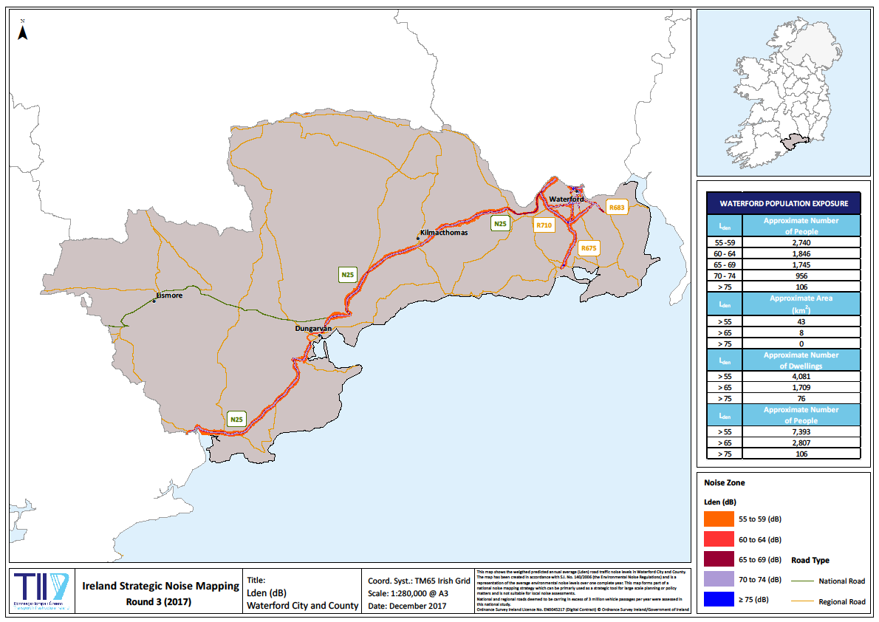 APPENDIX 3: Lden (dB) levels Waterford City and County

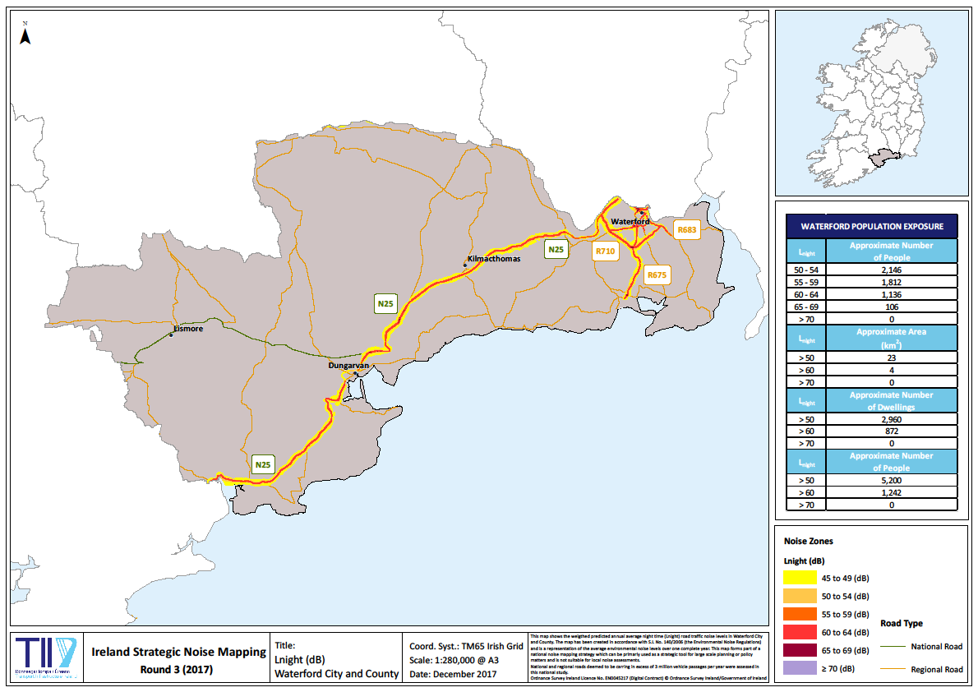 APPENDIX 4: Lnight (dB) levels Waterford City and County

APPENDIX 5: Buildings with score >17 identified for further assessment (location maps)

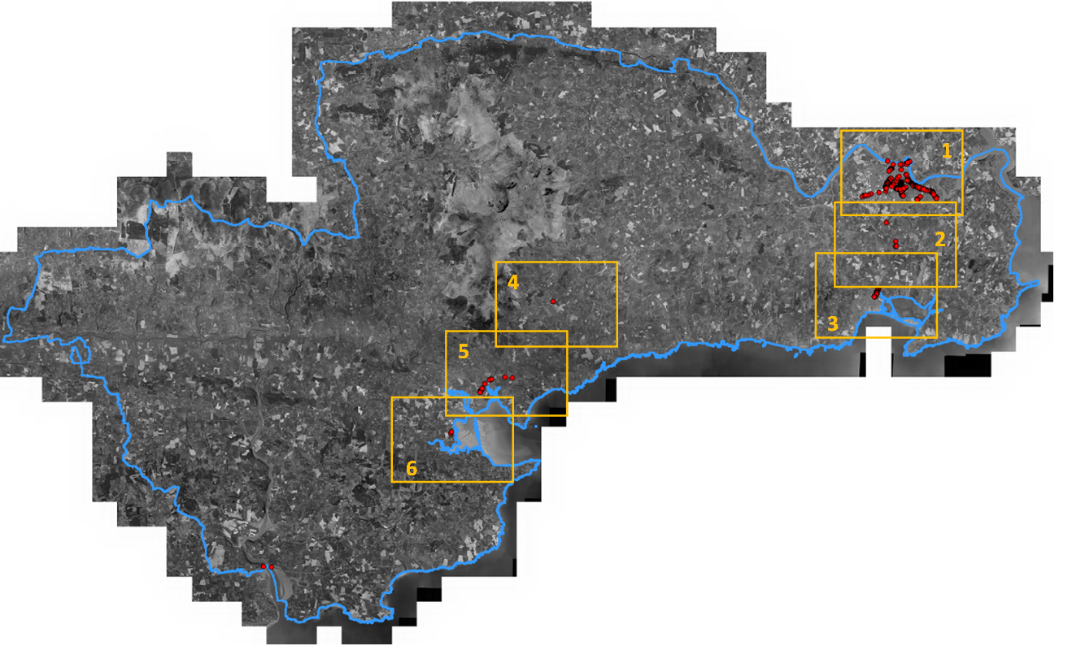

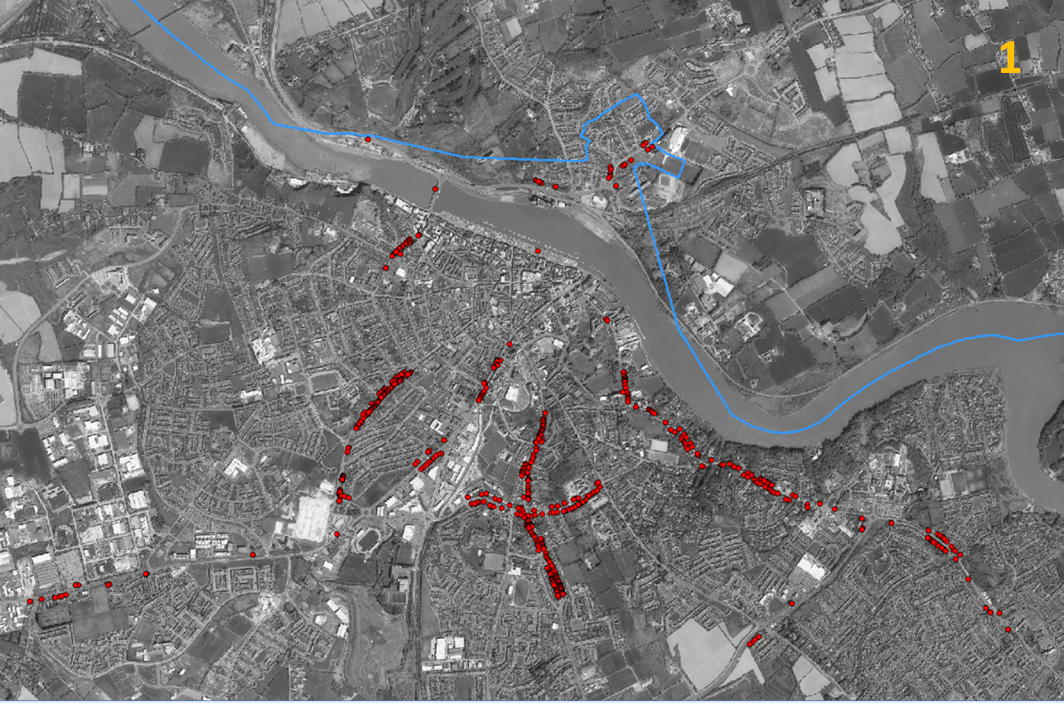
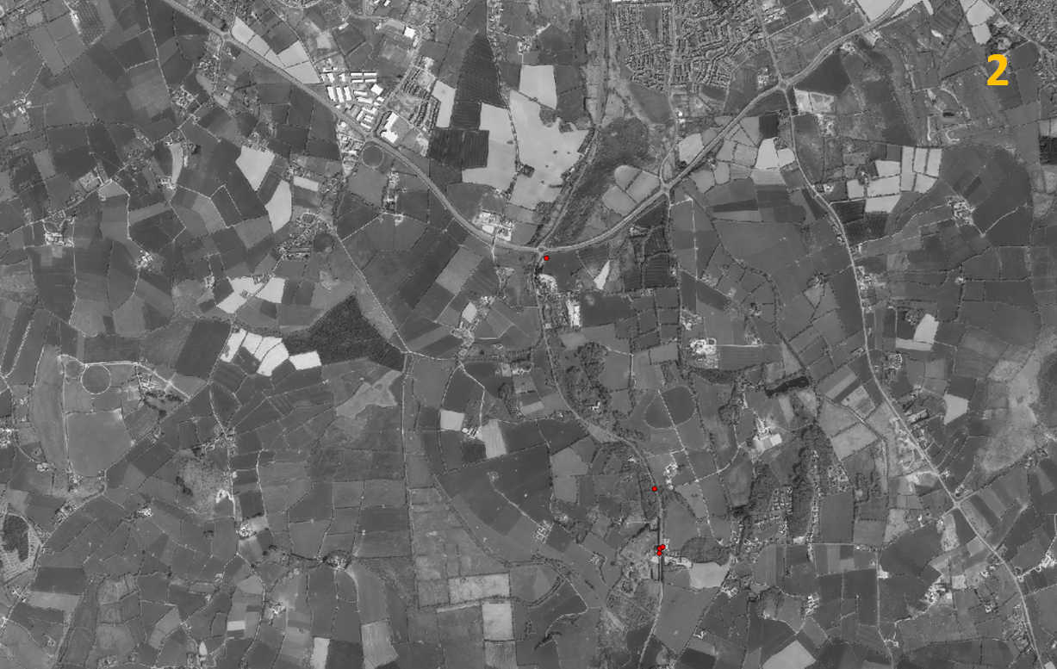
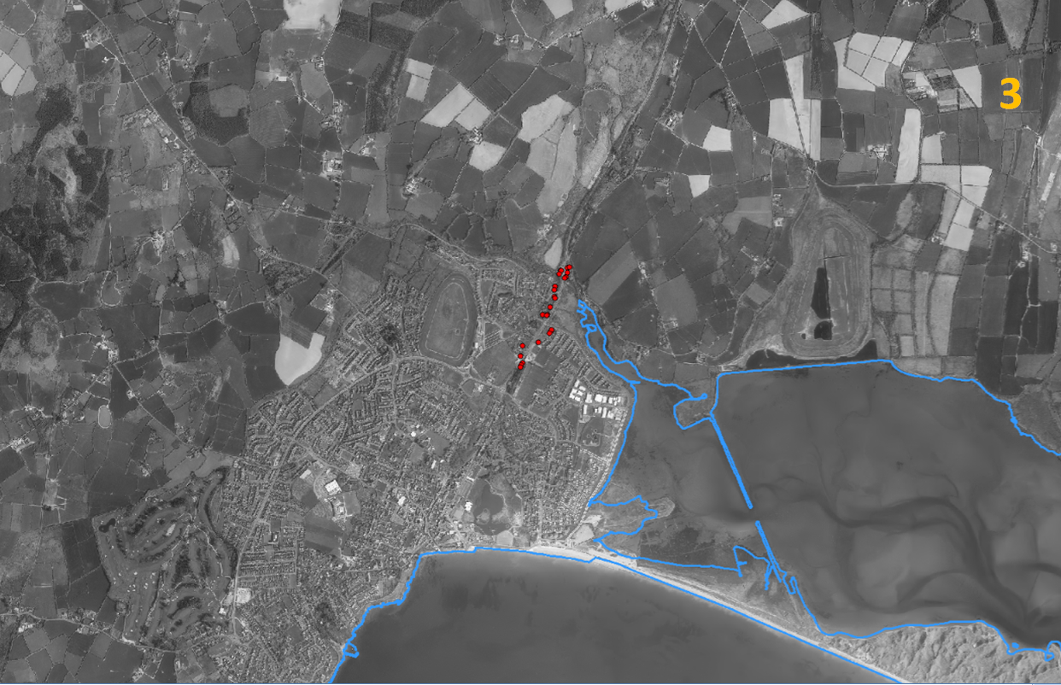
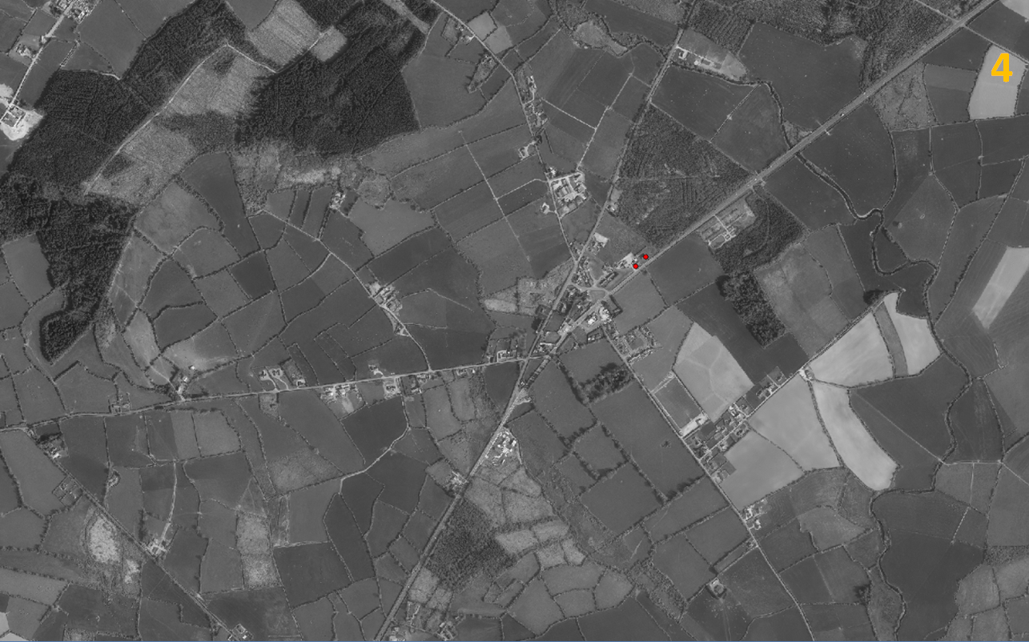
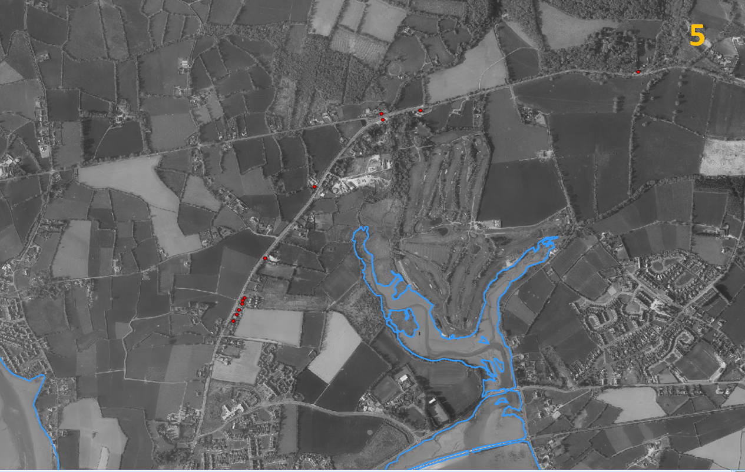
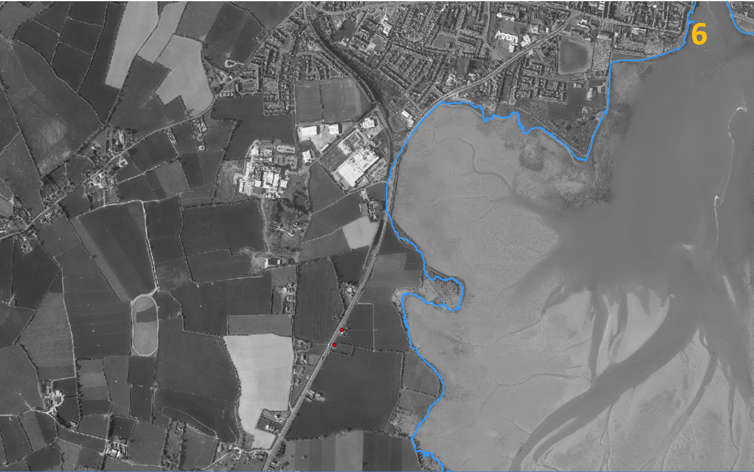

APPENDIX 6: Buildings with score >17 identified for further assessment (data table with coordinates)

Total Score | Lden Score | Lnight Score | Noise Source  Score Lden | Noise Source Score  Lnight | Location Score  Lden | Location Score  Lnight | X | Y | ID
19 | 4 | 6 | 3 | 4 | 1 | 1 | 260131.6 | 112651.5 | 7f4246ff-c_A
19 | 4 | 6 | 3 | 4 | 1 | 1 | 260126.4 | 112647.7 | 99e6687e-1_A
18 | 3 | 5 | 3 | 4 | 1 | 2 | 259630.4 | 110819.6 | 08b0e9bb-d_A
18 | 3 | 5 | 3 | 4 | 1 | 2 | 259821.7 | 113235 | 38327ec0-f_A
18 | 2 | 4 | 3 | 4 | 2 | 3 | 263258.6 | 110841.9 | c15b142c-a_A
18 | 2 | 4 | 3 | 4 | 2 | 3 | 263340.2 | 110800.8 | f6d88209-9_A
18 | 2 | 4 | 3 | 4 | 2 | 3 | 263317.6 | 110818.2 | cd0c51f7-4_A
18 | 2 | 4 | 3 | 4 | 2 | 3 | 263333 | 110807.9 | 50b845e6-c_A
18 | 2 | 4 | 3 | 4 | 2 | 3 | 263302.4 | 110760.3 | e61ed862-2_A
18 | 2 | 4 | 3 | 4 | 2 | 3 | 263306.2 | 110757.6 | 39483263-4_A
18 | 2 | 4 | 3 | 4 | 2 | 3 | 263274 | 110781.9 | e075bf16-0_A
18 | 2 | 4 | 3 | 4 | 2 | 3 | 263261.3 | 110790.9 | 98731ee1-6_A
18 | 2 | 4 | 3 | 4 | 2 | 3 | 263283.8 | 110773.5 | 87ceb29e-3_A
18 | 2 | 4 | 3 | 4 | 2 | 3 | 263292.4 | 110768.9 | f5f41df6-c_A
18 | 2 | 4 | 3 | 4 | 2 | 3 | 263256.1 | 110794.6 | fbb28e35-2_A
18 | 2 | 4 | 3 | 4 | 2 | 3 | 263350.3 | 110794.3 | 1121bca5-e_A
18 | 2 | 4 | 3 | 4 | 2 | 3 | 263360 | 110779.9 | 81c7849e-6_A
18 | 2 | 4 | 3 | 4 | 2 | 3 | 263371.3 | 110771.2 | 0efea059-6_A
18 | 2 | 4 | 3 | 4 | 2 | 3 | 263357.5 | 110788.2 | ef5c09d1-3_A
18 | 2 | 4 | 3 | 4 | 2 | 3 | 263347.4 | 110726.5 | 057eaf38-a_A
18 | 2 | 4 | 3 | 4 | 2 | 3 | 263352.2 | 110722.5 | 05e506e3-9_A
18 | 2 | 4 | 3 | 4 | 2 | 3 | 263396.9 | 110739.6 | b3db242d-6_A
18 | 2 | 4 | 3 | 4 | 2 | 3 | 263411.4 | 110717.2 | 09b56f2b-1_A
18 | 2 | 4 | 3 | 4 | 2 | 3 | 263420 | 110712.3 | b47c9529-4_A
18 | 2 | 4 | 3 | 4 | 2 | 3 | 263363.1 | 110712.3 | e548057b-0_A
18 | 2 | 4 | 3 | 4 | 2 | 3 | 263452.1 | 110689.9 | 9837b2ee-2_A
18 | 2 | 4 | 3 | 4 | 2 | 3 | 263427.4 | 110666 | 95044dc0-d_A
18 | 2 | 4 | 3 | 4 | 2 | 3 | 263328.7 | 110743.1 | 1241fee1-f_A
18 | 2 | 4 | 3 | 4 | 2 | 3 | 263320.3 | 110747.6 | d21d36a9-5_A
18 | 2 | 4 | 3 | 4 | 2 | 3 | 263338 | 110733.4 | 41eedac1-9_A
18 | 2 | 4 | 3 | 4 | 2 | 3 | 263031.1 | 110887.2 | 92fd9769-d_A
18 | 2 | 4 | 3 | 4 | 2 | 3 | 263695.6 | 110332.1 | 2895c2fd-4_A
18 | 2 | 4 | 3 | 4 | 2 | 3 | 263610.4 | 110364.2 | b8cb961e-f_A
18 | 2 | 4 | 3 | 4 | 2 | 3 | 263638.2 | 110339 | 3b4b8bc0-b_A
18 | 2 | 4 | 3 | 4 | 2 | 3 | 263747.7 | 110235.5 | 9c5b41ae-8_A
18 | 2 | 4 | 3 | 4 | 2 | 3 | 263504.1 | 110541.5 | 2195900d-6_A
18 | 2 | 4 | 3 | 4 | 2 | 3 | 260886.6 | 112969.4 | 7b6a2334-d_A
18 | 2 | 4 | 3 | 4 | 2 | 3 | 260972.7 | 112949.5 | 7fd24888-9_A
18 | 2 | 4 | 3 | 4 | 2 | 3 | 261308.1 | 113067.4 | 80054c72-1_A
18 | 2 | 4 | 3 | 4 | 2 | 3 | 261312.1 | 113054.4 | fae47df8-1_A
18 | 2 | 4 | 3 | 4 | 2 | 3 | 261525.8 | 113213.8 | 2f559580-b_A
18 | 2 | 4 | 3 | 4 | 2 | 3 | 261508.5 | 113199.3 | 8ba800f9-3_A
18 | 2 | 4 | 3 | 4 | 2 | 3 | 261381.4 | 113072.2 | fa2206af-9_A
18 | 2 | 4 | 3 | 4 | 2 | 3 | 261394.9 | 113081 | ac281f7c-9_A
18 | 2 | 4 | 3 | 4 | 2 | 3 | 261304 | 113027.7 | c80b2d33-8_A
20 | 3 | 5 | 3 | 4 | 2 | 3 | 261306.5 | 113014.6 | b1f33653-b_A
20 | 3 | 5 | 3 | 4 | 2 | 3 | 261304.9 | 113008.5 | 1f1218c8-c_A
18 | 2 | 4 | 3 | 4 | 2 | 3 | 261298.4 | 113000 | 3491f100-2_A
18 | 2 | 4 | 3 | 4 | 2 | 3 | 261562.9 | 113191.2 | 4e76f1d8-7_A
18 | 2 | 4 | 3 | 4 | 2 | 3 | 261539.6 | 111584.4 | c93b382c-e_A

Total Score | Lden Score | Lnight Score | Noise Source  Score Lden | Noise Source Score  Lnight | Location Score  Lden | Location Score  Lnight | X | Y | ID
18 | 2 | 4 | 3 | 4 | 2 | 3 | 261547.7 | 111578.4 | f861a717-6_A
18 | 2 | 4 | 3 | 4 | 2 | 3 | 261928.9 | 111272.1 | 240165d0-3_A
18 | 2 | 4 | 3 | 4 | 2 | 3 | 261553.9 | 111573.8 | 2258ebaf-8_A
18 | 2 | 4 | 3 | 4 | 2 | 3 | 261560.1 | 111569.1 | c3fdd807-4_A
18 | 2 | 4 | 3 | 4 | 2 | 3 | 261572.4 | 111560 | b16e482b-f_A
18 | 2 | 4 | 3 | 4 | 2 | 3 | 261566.3 | 111564.5 | 82cf186d-0_A
18 | 2 | 4 | 3 | 4 | 2 | 3 | 261578.5 | 111555.5 | d08ac5df-b_A
18 | 2 | 4 | 3 | 4 | 2 | 3 | 261644.4 | 111504.3 | f0ae85e1-c_A
18 | 2 | 4 | 3 | 4 | 2 | 3 | 261698.8 | 111444.9 | 630dc098-c_A
18 | 2 | 4 | 3 | 4 | 2 | 3 | 261733.1 | 111460.1 | 6a6118e5-c_A
18 | 2 | 4 | 3 | 4 | 2 | 3 | 261758.4 | 111428.4 | 31a5fab7-b_A
18 | 2 | 4 | 3 | 4 | 2 | 3 | 261773.2 | 111413 | b18e7ccf-7_A
18 | 2 | 4 | 3 | 4 | 2 | 3 | 261745.3 | 111413.1 | c71518d3-c_A
18 | 2 | 4 | 3 | 4 | 2 | 3 | 261750.5 | 111395.4 | e2514a65-1_A
18 | 2 | 4 | 3 | 4 | 2 | 3 | 261754.3 | 111389.7 | f50a35a6-e_A
18 | 2 | 4 | 3 | 4 | 2 | 3 | 261747.8 | 111399.3 | adb7be11-f_A
18 | 2 | 4 | 3 | 4 | 2 | 3 | 261758.3 | 111383.7 | 6ef489f3-7_A
18 | 2 | 4 | 3 | 4 | 2 | 3 | 261762.3 | 111377.6 | 6477521b-3_A
18 | 2 | 4 | 3 | 4 | 2 | 3 | 261766 | 111371.9 | 70f52140-0_A
18 | 2 | 4 | 3 | 4 | 2 | 3 | 261773.9 | 111353.8 | 1b18f876-6_A
18 | 2 | 4 | 3 | 4 | 2 | 3 | 261782.5 | 111341 | 0c4065a2-9_A
18 | 2 | 4 | 3 | 4 | 2 | 3 | 261799.1 | 111373.5 | 68c17793-4_A
18 | 2 | 4 | 3 | 4 | 2 | 3 | 261811 | 111350.9 | f2b42c33-c_A
18 | 2 | 4 | 3 | 4 | 2 | 3 | 261845.8 | 111303.7 | 4d59e77b-0_A
18 | 2 | 4 | 3 | 4 | 2 | 3 | 261840 | 111311.1 | 8f042778-3_A
18 | 2 | 4 | 3 | 4 | 2 | 3 | 262851.5 | 110914.1 | 3802db6e-8_A
18 | 2 | 4 | 3 | 4 | 2 | 3 | 262855.4 | 110855.4 | 8f3b2e55-d_A
18 | 2 | 4 | 3 | 4 | 2 | 3 | 262851.4 | 110846.1 | f687d8aa-d_A
18 | 2 | 4 | 3 | 4 | 2 | 3 | 261878.1 | 111231.5 | b3d3aedd-9_A
18 | 2 | 4 | 3 | 4 | 2 | 3 | 261869.9 | 111233 | c6228e06-1_A
18 | 2 | 4 | 3 | 4 | 2 | 3 | 261991.4 | 111242.6 | 2c229ec3-6_A
18 | 2 | 4 | 3 | 4 | 2 | 3 | 261999.4 | 111245.4 | fcc39f5d-f_A
20 | 3 | 5 | 3 | 4 | 2 | 3 | 262068.9 | 111231 | c4c577ea-9_A
18 | 2 | 4 | 3 | 4 | 2 | 3 | 262041.4 | 111247.6 | 637fe8a8-0_A
18 | 2 | 4 | 3 | 4 | 2 | 3 | 262092.4 | 111221.1 | 5f20f1d6-9_A
18 | 2 | 4 | 3 | 4 | 2 | 3 | 262155.4 | 111194.1 | 3c7eccec-2_A
18 | 2 | 4 | 3 | 4 | 2 | 3 | 262173.5 | 111182 | 2ed6e70d-e_A
18 | 2 | 4 | 3 | 4 | 2 | 3 | 262124.5 | 111181 | f96ab4c4-7_A
18 | 2 | 4 | 3 | 4 | 2 | 3 | 262149.4 | 111168.5 | 3acb9433-2_A
18 | 2 | 4 | 3 | 4 | 2 | 3 | 262188.5 | 111152.8 | 55f9da03-4_A
18 | 2 | 4 | 3 | 4 | 2 | 3 | 262280.7 | 111129.3 | 64a7e800-4_A
18 | 2 | 4 | 3 | 4 | 2 | 3 | 262284.1 | 111127.5 | 2ff195dc-3_A
18 | 2 | 4 | 3 | 4 | 2 | 3 | 262293.3 | 111121.2 | 135fc97b-4_A
18 | 2 | 4 | 3 | 4 | 2 | 3 | 262299.9 | 111118.8 | 1b62734b-a_A
18 | 2 | 4 | 3 | 4 | 2 | 3 | 262281 | 111093 | 010379f3-9_A
18 | 2 | 4 | 3 | 4 | 2 | 3 | 262287.1 | 111088.8 | 0730c6ac-8_A
20 | 3 | 5 | 3 | 4 | 2 | 3 | 262204.1 | 111148.4 | 9c1e2541-5_A
18 | 2 | 4 | 3 | 4 | 2 | 3 | 262230 | 111156.3 | 3fc12902-a_A
18 | 2 | 4 | 3 | 4 | 2 | 3 | 262209.6 | 111134.4 | 402ce1c6-e_A
18 | 2 | 4 | 3 | 4 | 2 | 3 | 262224 | 111128 | fbf844b2-e_A

Total Score | Lden Score | Lnight Score | Noise Source  Score Lden | Noise Source Score  Lnight | Location Score  Lden | Location Score  Lnight | X | Y | ID
18 | 2 | 4 | 3 | 4 | 2 | 3 | 262236.6 | 111153.8 | bc201695-c_A
18 | 2 | 4 | 3 | 4 | 2 | 3 | 262245.7 | 111147.5 | f3af051d-6_A
18 | 2 | 4 | 3 | 4 | 2 | 3 | 262261.4 | 111138.9 | acb421cf-1_A
18 | 2 | 4 | 3 | 4 | 2 | 3 | 262268.3 | 111136.2 | 9059f5d6-8_A
18 | 2 | 4 | 3 | 4 | 2 | 3 | 262254.6 | 111142.6 | 9a4d700f-8_A
18 | 2 | 4 | 3 | 4 | 2 | 3 | 262258.5 | 111107.5 | 5ab20030-c_A
18 | 2 | 4 | 3 | 4 | 2 | 3 | 262423.1 | 111056 | e46d5b35-5_A
18 | 2 | 4 | 3 | 4 | 2 | 3 | 262401.4 | 111025.1 | 95d9e549-a_A
18 | 2 | 4 | 3 | 4 | 2 | 3 | 262382.7 | 111033.2 | a04ebc24-8_A
18 | 2 | 4 | 3 | 4 | 2 | 3 | 262442.1 | 111050.8 | e5d73cf0-9_A
18 | 2 | 4 | 3 | 4 | 2 | 3 | 262516.2 | 110999.9 | 2625a783-7_A
18 | 2 | 4 | 3 | 4 | 2 | 3 | 262515.1 | 110982.4 | df440609-8_A
18 | 2 | 4 | 3 | 4 | 2 | 3 | 262298.7 | 111082 | 3455aaa3-3_A
18 | 2 | 4 | 3 | 4 | 2 | 3 | 262312.2 | 111073.7 | 2f4d9736-a_A
18 | 2 | 4 | 3 | 4 | 2 | 3 | 262336.1 | 111069.2 | 1703b1a5-8_A
18 | 2 | 4 | 3 | 4 | 2 | 3 | 262593 | 111005.3 | a7137351-7_A
18 | 2 | 4 | 3 | 4 | 2 | 3 | 261277.5 | 112135.7 | 072d5c79-1_A
18 | 2 | 4 | 3 | 4 | 2 | 3 | 261286.4 | 112128.1 | dfde702e-5_A
18 | 2 | 4 | 3 | 4 | 2 | 3 | 261391 | 111804.7 | e30c10ae-3_A
18 | 2 | 4 | 3 | 4 | 2 | 3 | 261389.1 | 111811.8 | 6d4c8123-b_A
18 | 2 | 4 | 3 | 4 | 2 | 3 | 261393.7 | 111786.6 | 0f36695d-1_A
18 | 2 | 4 | 3 | 4 | 2 | 3 | 261395.8 | 111773.5 | ffa98514-4_A
18 | 2 | 4 | 3 | 4 | 2 | 3 | 261396.8 | 111767.4 | b758e65e-a_A
18 | 2 | 4 | 3 | 4 | 2 | 3 | 261397.8 | 111761.5 | 79d8150e-7_A
18 | 2 | 4 | 3 | 4 | 2 | 3 | 261398.9 | 111755.3 | b15d149f-8_A
18 | 2 | 4 | 3 | 4 | 2 | 3 | 261395.4 | 111749.3 | ba537c3b-f_A
18 | 2 | 4 | 3 | 4 | 2 | 3 | 261397.9 | 111734.1 | d252e2d0-8_A
18 | 2 | 4 | 3 | 4 | 2 | 3 | 261401.4 | 111713.3 | e920cce6-7_A
18 | 2 | 4 | 3 | 4 | 2 | 3 | 261400.8 | 111716.7 | 76b962ea-c_A
18 | 2 | 4 | 3 | 4 | 2 | 3 | 261405.5 | 111686.6 | 4f1f5482-a_A
18 | 2 | 4 | 3 | 4 | 2 | 3 | 261415.2 | 111670.5 | 928c7b84-1_A
18 | 2 | 4 | 3 | 4 | 2 | 3 | 261466 | 111596.7 | 99ccfad1-8_A
18 | 2 | 4 | 3 | 4 | 2 | 3 | 261413.1 | 111657.7 | 0027f5bd-9_A
18 | 2 | 4 | 3 | 4 | 2 | 3 | 261413.2 | 111650.4 | 64cd30f8-f_A
18 | 2 | 4 | 3 | 4 | 2 | 3 | 261414.2 | 111643.8 | 5d60feed-1_A
18 | 2 | 4 | 3 | 4 | 2 | 3 | 261416.9 | 111628.4 | 78ab71a1-a_A
18 | 2 | 4 | 3 | 4 | 2 | 3 | 260909.4 | 111562 | f2ea5746-a_A
18 | 2 | 4 | 3 | 4 | 2 | 3 | 260896.9 | 111526.9 | de3659f9-4_A
18 | 2 | 4 | 3 | 4 | 2 | 3 | 260894.6 | 111520.6 | 8167e80f-e_A
18 | 2 | 4 | 3 | 4 | 2 | 3 | 260894.2 | 111512.5 | 4540c3c5-8_A
18 | 2 | 4 | 3 | 4 | 2 | 3 | 260893.4 | 111496.5 | 6570da3e-8_A
18 | 2 | 4 | 3 | 4 | 2 | 3 | 260893.8 | 111504.4 | 687ecdca-8_A
18 | 2 | 4 | 3 | 4 | 2 | 3 | 260893 | 111488.6 | 52b1dfef-a_A
18 | 2 | 4 | 3 | 4 | 2 | 3 | 260892.6 | 111480.5 | 50f48be1-f_A
18 | 2 | 4 | 3 | 4 | 2 | 3 | 260888.4 | 111465.4 | cbce8808-3_A
18 | 2 | 4 | 3 | 4 | 2 | 3 | 260885.8 | 111457.9 | 62f9498e-f_A
18 | 2 | 4 | 3 | 4 | 2 | 3 | 260887.6 | 111395.3 | 88367851-b_A
18 | 2 | 4 | 3 | 4 | 2 | 3 | 260886.2 | 111382.5 | a64649e7-e_A
18 | 2 | 4 | 3 | 4 | 2 | 3 | 261124.3 | 111005.5 | 5717861c-1_A
18 | 2 | 4 | 3 | 4 | 2 | 3 | 261164.5 | 111047 | 9f42945a-f_A

Total Score | Lden Score | Lnight Score | Noise Source  Score Lden | Noise Source Score  Lnight | Location Score  Lden | Location Score  Lnight | X | Y | ID
18 | 2 | 4 | 3 | 4 | 2 | 3 | 261189.4 | 111065 | 7eb0d360-8_A
18 | 2 | 4 | 3 | 4 | 2 | 3 | 261207.6 | 111075.2 | 6770618b-9_A
18 | 2 | 4 | 3 | 4 | 2 | 3 | 261173.2 | 111053.6 | c8e09f6d-1_A
18 | 2 | 4 | 3 | 4 | 2 | 3 | 261154.8 | 111025.9 | 81a4f120-b_A
18 | 2 | 4 | 3 | 4 | 2 | 3 | 261143.9 | 111018.8 | 45afe1ec-8_A
18 | 2 | 4 | 3 | 4 | 2 | 3 | 261135.8 | 111012.6 | e3a4c9f9-a_A
18 | 2 | 4 | 3 | 4 | 2 | 3 | 261076.7 | 110978.5 | 03bdfb65-6_A
18 | 2 | 4 | 3 | 4 | 2 | 3 | 261082.4 | 110981.9 | 318ec2ce-d_A
18 | 2 | 4 | 3 | 4 | 2 | 3 | 261058.8 | 110970.9 | e0f943ce-4_A
18 | 2 | 4 | 3 | 4 | 2 | 3 | 261069.2 | 110974.6 | 2f456a43-4_A
18 | 2 | 4 | 3 | 4 | 2 | 3 | 261103 | 110993.4 | 0278bef0-8_A
18 | 2 | 4 | 3 | 4 | 2 | 3 | 261093.5 | 110987.7 | 7dbc40da-5_A
18 | 2 | 4 | 3 | 4 | 2 | 3 | 261116.2 | 111001.2 | 288d3d99-4_A
18 | 2 | 4 | 3 | 4 | 2 | 3 | 261109.3 | 110997.1 | 920739db-8_A
18 | 2 | 4 | 3 | 4 | 2 | 3 | 261025.6 | 111010.2 | 9c8ff1f7-c_A
18 | 2 | 4 | 3 | 4 | 2 | 3 | 260986.1 | 110990.2 | 1a28f01e-8_A
18 | 2 | 4 | 3 | 4 | 2 | 3 | 261039.8 | 110964.1 | fc70dc3a-d_A
18 | 2 | 4 | 3 | 4 | 2 | 3 | 261046 | 110966.3 | b7968721-7_A
18 | 2 | 4 | 3 | 4 | 2 | 3 | 261027.3 | 110959.6 | 98598405-a_A
18 | 2 | 4 | 3 | 4 | 2 | 3 | 261021.1 | 110957.3 | 1c1bde66-0_A
18 | 2 | 4 | 3 | 4 | 2 | 3 | 260978.5 | 110956.1 | 8d0e8a12-8_A
18 | 2 | 4 | 3 | 4 | 2 | 3 | 260948 | 110983.8 | 2d87b078-b_A
18 | 2 | 4 | 3 | 4 | 2 | 3 | 260943.4 | 110951.4 | 16656ba1-d_A
18 | 2 | 4 | 3 | 4 | 2 | 3 | 260958.4 | 110949.3 | 3c8692cc-9_A
18 | 2 | 4 | 3 | 4 | 2 | 3 | 260887.6 | 110939 | 007350dc-4_A
18 | 2 | 4 | 3 | 4 | 2 | 3 | 261244.9 | 111108.4 | ccebccd6-b_A
18 | 2 | 4 | 3 | 4 | 2 | 3 | 261226 | 111087.3 | cbc6888e-2_A
18 | 2 | 4 | 3 | 4 | 2 | 3 | 260884.1 | 110785.7 | 02ff824e-4_A
18 | 2 | 4 | 3 | 4 | 2 | 3 | 260886.4 | 110776.2 | 10f1474c-e_A
18 | 2 | 4 | 3 | 4 | 2 | 3 | 260888.4 | 110758.3 | f87b9e5a-7_A
18 | 2 | 4 | 3 | 4 | 2 | 3 | 260886.1 | 110767.6 | 1211dff4-b_A
18 | 2 | 4 | 3 | 4 | 2 | 3 | 260889.8 | 110752.9 | e37804c9-0_A
18 | 2 | 4 | 3 | 4 | 2 | 3 | 260891.2 | 110747.5 | 80b8dc42-8_A
18 | 2 | 4 | 3 | 4 | 2 | 3 | 260892.9 | 110739.9 | a2ed5eef-d_A
18 | 2 | 4 | 3 | 4 | 2 | 3 | 260894.2 | 110734.3 | a46ff567-d_A
18 | 2 | 4 | 3 | 4 | 2 | 3 | 260898.1 | 110729.5 | 5d10ed2b-8_A
18 | 2 | 4 | 3 | 4 | 2 | 3 | 260910 | 110699.7 | 352e7b4b-7_A
18 | 2 | 4 | 3 | 4 | 2 | 3 | 260912.7 | 110684.3 | 2652a132-b_A
18 | 2 | 4 | 3 | 4 | 2 | 3 | 260918.7 | 110673.4 | 0bfb9cd1-a_A
18 | 2 | 4 | 3 | 4 | 2 | 3 | 260923.5 | 110664.7 | ba12754e-5_A
18 | 2 | 4 | 3 | 4 | 2 | 3 | 260929.4 | 110653.9 | 543ab069-4_A
18 | 2 | 4 | 3 | 4 | 2 | 3 | 260939.7 | 110635.3 | 0dae5515-0_A
18 | 2 | 4 | 3 | 4 | 2 | 3 | 260934 | 110645.7 | fb267396-d_A
18 | 2 | 4 | 3 | 4 | 2 | 3 | 260952.8 | 110612 | 64c17bd5-6_A
18 | 2 | 4 | 3 | 4 | 2 | 3 | 260946.8 | 110621.2 | e24789e1-d_A
18 | 2 | 4 | 3 | 4 | 2 | 3 | 260926.4 | 110606.3 | 61ad12cc-8_A
18 | 2 | 4 | 3 | 4 | 2 | 3 | 260929.4 | 110600.6 | ae531770-7_A
18 | 2 | 4 | 3 | 4 | 2 | 3 | 260932.4 | 110595.1 | 1cac0684-4_A
18 | 2 | 4 | 3 | 4 | 2 | 3 | 260923.4 | 110612 | 80aebbcc-d_A
18 | 2 | 4 | 3 | 4 | 2 | 3 | 260935.4 | 110589.4 | 50f12663-4_A

Total Score | Lden Score | Lnight Score | Noise Source  Score Lden | Noise Source Score  Lnight | Location Score  Lden | Location Score  Lnight | X | Y | ID
18 | 2 | 4 | 3 | 4 | 2 | 3 | 260938.4 | 110583.7 | 964c0ce7-0_A
18 | 2 | 4 | 3 | 4 | 2 | 3 | 260941.3 | 110578.1 | 54601d38-5_A
18 | 2 | 4 | 3 | 4 | 2 | 3 | 260947.3 | 110566.8 | 79736979-5_A
18 | 2 | 4 | 3 | 4 | 2 | 3 | 260949 | 110556.3 | 3ee32903-4_A
18 | 2 | 4 | 3 | 4 | 2 | 3 | 260944.2 | 110572.6 | 3d96a84d-1_A
18 | 2 | 4 | 3 | 4 | 2 | 3 | 260948.7 | 110547.5 | c2bff964-6_A
18 | 2 | 4 | 3 | 4 | 2 | 3 | 260954.2 | 110532.3 | 341f67a2-e_A
18 | 2 | 4 | 3 | 4 | 2 | 3 | 260950.5 | 110542.4 | 189706f8-7_A
18 | 2 | 4 | 3 | 4 | 2 | 3 | 260952.3 | 110537.4 | c2612942-d_A
18 | 2 | 4 | 3 | 4 | 2 | 3 | 260956 | 110527.1 | f3ac0794-6_A
18 | 2 | 4 | 3 | 4 | 2 | 3 | 260957.9 | 110521.9 | 4ec62f98-2_A
18 | 2 | 4 | 3 | 4 | 2 | 3 | 260961.5 | 110511.7 | 4aaaf71b-0_A
18 | 2 | 4 | 3 | 4 | 2 | 3 | 260959.6 | 110516.8 | 04b8072e-f_A
18 | 2 | 4 | 3 | 4 | 2 | 3 | 260969.8 | 110573.1 | 33a1a568-7_A
18 | 2 | 4 | 3 | 4 | 2 | 3 | 260967.5 | 110579 | 2e6a3985-2_A
18 | 2 | 4 | 3 | 4 | 2 | 3 | 260965 | 110585.1 | d6248c18-5_A
18 | 2 | 4 | 3 | 4 | 2 | 3 | 260972.1 | 110567.2 | e656e7cc-3_A
18 | 2 | 4 | 3 | 4 | 2 | 3 | 260974.5 | 110561.2 | 7e8daab7-f_A
18 | 2 | 4 | 3 | 4 | 2 | 3 | 260976.8 | 110555.3 | 30303a9a-1_A
18 | 2 | 4 | 3 | 4 | 2 | 3 | 260979.1 | 110549.4 | 2d9cf996-a_A
18 | 2 | 4 | 3 | 4 | 2 | 3 | 260983.8 | 110537.6 | 66fdf616-4_A
18 | 2 | 4 | 3 | 4 | 2 | 3 | 260981.5 | 110543.4 | 36cb9a86-9_A
18 | 2 | 4 | 3 | 4 | 2 | 3 | 260986.1 | 110531.8 | e6a0a426-6_A
18 | 2 | 4 | 3 | 4 | 2 | 3 | 260990.7 | 110527.2 | 74972e2b-7_A
18 | 2 | 4 | 3 | 4 | 2 | 3 | 260994.8 | 110517 | 5c7b39e6-9_A
18 | 2 | 4 | 3 | 4 | 2 | 3 | 260992.8 | 110522.2 | 5fa928de-5_A
18 | 2 | 4 | 3 | 4 | 2 | 3 | 260996.9 | 110511.7 | 5fc27849-8_A
18 | 2 | 4 | 3 | 4 | 2 | 3 | 260975 | 110492.1 | 1f539c74-3_A
18 | 2 | 4 | 3 | 4 | 2 | 3 | 260965.1 | 110501.5 | 89c60925-a_A
18 | 2 | 4 | 3 | 4 | 2 | 3 | 260998.9 | 110506.9 | 48b237e6-1_A
18 | 2 | 4 | 3 | 4 | 2 | 3 | 261000.9 | 110501.9 | 6f75fcde-b_A
18 | 2 | 4 | 3 | 4 | 2 | 3 | 261002.9 | 110496.7 | 098ae890-2_A
18 | 2 | 4 | 3 | 4 | 2 | 3 | 261004.9 | 110491.7 | d1801d9b-a_A
18 | 2 | 4 | 3 | 4 | 2 | 3 | 261003.7 | 110484.8 | 3a1b2e45-3_A
18 | 2 | 4 | 3 | 4 | 2 | 3 | 260976.3 | 110485.8 | 70dbd11d-d_A
18 | 2 | 4 | 3 | 4 | 2 | 3 | 260977.5 | 110479.6 | c8d6ee0c-0_A
18 | 2 | 4 | 3 | 4 | 2 | 3 | 260978.7 | 110473.5 | 52099347-6_A
18 | 2 | 4 | 3 | 4 | 2 | 3 | 261008.4 | 110472.8 | b1c0ec59-b_A
18 | 2 | 4 | 3 | 4 | 2 | 3 | 261006.1 | 110478.8 | 2c1a76eb-0_A
18 | 2 | 4 | 3 | 4 | 2 | 3 | 261010.7 | 110466.9 | 5492fbad-8_A
18 | 2 | 4 | 3 | 4 | 2 | 3 | 261012.9 | 110461.2 | 5d953499-6_A
18 | 2 | 4 | 3 | 4 | 2 | 3 | 261015.1 | 110455.4 | dc37811a-c_A
18 | 2 | 4 | 3 | 4 | 2 | 3 | 261017.4 | 110449.5 | b5c6d905-5_A
18 | 2 | 4 | 3 | 4 | 2 | 3 | 260979.9 | 110467.2 | e1e8c621-9_A
18 | 2 | 4 | 3 | 4 | 2 | 3 | 260982.4 | 110454.8 | 0d314313-9_A
18 | 2 | 4 | 3 | 4 | 2 | 3 | 260981.2 | 110461 | 7c0e6a48-b_A
18 | 2 | 4 | 3 | 4 | 2 | 3 | 260988 | 110433.1 | 3fbad894-7_A
18 | 2 | 4 | 3 | 4 | 2 | 3 | 260983.6 | 110448.4 | 7b8871e6-7_A
18 | 2 | 4 | 3 | 4 | 2 | 3 | 260984.9 | 110442.1 | 602682bb-e_A
18 | 2 | 4 | 3 | 4 | 2 | 3 | 260963.3 | 110506.7 | 69582917-9_A

Total Score | Lden Score | Lnight Score | Noise Source  Score Lden | Noise Source Score  Lnight | Location Score  Lden | Location Score  Lnight | X | Y | ID
18 | 2 | 4 | 3 | 4 | 2 | 3 | 262217.1 | 110189.1 | e24a1e4f-1_A
18 | 2 | 4 | 3 | 4 | 2 | 3 | 262193.4 | 110168.8 | dcb2d491-8_A
18 | 2 | 4 | 3 | 4 | 2 | 3 | 262177.6 | 110152.3 | 3e484b79-0_A
18 | 2 | 4 | 3 | 4 | 2 | 3 | 262162.5 | 110141.5 | b426f845-6_A
18 | 2 | 4 | 3 | 4 | 2 | 3 | 260849.9 | 112986 | e2ad1875-6_A
18 | 2 | 4 | 3 | 4 | 2 | 3 | 260858.9 | 112983 | 988406fe-7_A
18 | 2 | 4 | 3 | 4 | 2 | 3 | 260877.5 | 112977.1 | e0dff933-9_A
18 | 2 | 4 | 3 | 4 | 2 | 3 | 260868.5 | 112979.7 | 9f661403-c_A
18 | 2 | 4 | 3 | 4 | 2 | 3 | 260075.1 | 112624.5 | 73646342-d_A
18 | 2 | 4 | 3 | 4 | 2 | 3 | 260077.4 | 112616 | 8f3b74d1-4_A
18 | 2 | 4 | 3 | 4 | 2 | 3 | 260071.3 | 112612.8 | 3e213307-9_A
20 | 3 | 5 | 3 | 4 | 2 | 3 | 260067.5 | 112604.9 | eca38e10-4_A
18 | 2 | 4 | 3 | 4 | 2 | 3 | 260055.6 | 112601.7 | f5afa1cb-a_A
18 | 2 | 4 | 3 | 4 | 2 | 3 | 260052 | 112601.3 | 3495715d-d_A
18 | 2 | 4 | 3 | 4 | 2 | 3 | 260044.7 | 112595.3 | 9b189bbf-5_A
18 | 2 | 4 | 3 | 4 | 2 | 3 | 260022.7 | 112577.2 | 6782ff4b-8_A
18 | 2 | 4 | 3 | 4 | 2 | 3 | 260033.3 | 112586.7 | 17c3d5a2-b_A
18 | 2 | 4 | 3 | 4 | 2 | 3 | 260028 | 112581.9 | 7678eac7-5_A
18 | 2 | 4 | 3 | 4 | 2 | 3 | 260017.3 | 112572.5 | 01d470cf-3_A
18 | 2 | 4 | 3 | 4 | 2 | 3 | 260004.7 | 112561.5 | dbf8bc26-a_A
18 | 2 | 4 | 3 | 4 | 2 | 3 | 260009.3 | 112565.5 | 2039d3f0-a_A
18 | 2 | 4 | 3 | 4 | 2 | 3 | 259979.9 | 112534 | f3cc7c71-5_A
18 | 2 | 4 | 3 | 4 | 2 | 3 | 259968.4 | 112523 | f24e34fb-9_A
18 | 2 | 4 | 3 | 4 | 2 | 3 | 259995.1 | 112553.1 | 105f2577-5_A
18 | 2 | 4 | 3 | 4 | 2 | 3 | 260018.6 | 112533.2 | 9c707ba3-8_A
18 | 2 | 4 | 3 | 4 | 2 | 3 | 259986.7 | 112545.7 | 346f64a7-f_A
18 | 2 | 4 | 3 | 4 | 2 | 3 | 259990.9 | 112549.3 | 93d7df7d-9_A
18 | 2 | 4 | 3 | 4 | 2 | 3 | 259887.3 | 111679.8 | 367f0c0d-5_A
18 | 2 | 4 | 3 | 4 | 2 | 3 | 259898.4 | 111652.9 | be0c1825-4_A
18 | 2 | 4 | 3 | 4 | 2 | 3 | 259895 | 111649.3 | 47e24a73-9_A
18 | 2 | 4 | 3 | 4 | 2 | 3 | 259891.7 | 111645.9 | 4624d848-9_A
18 | 2 | 4 | 3 | 4 | 2 | 3 | 259884.4 | 111633.1 | 22abba9c-c_A
18 | 2 | 4 | 3 | 4 | 2 | 3 | 259887.4 | 111636.7 | cff3fad4-b_A
18 | 2 | 4 | 3 | 4 | 2 | 3 | 259881.2 | 111629.3 | caf4cde1-4_A
18 | 2 | 4 | 3 | 4 | 2 | 3 | 259874.9 | 111621.8 | 9743f00b-b_A
18 | 2 | 4 | 3 | 4 | 2 | 3 | 259871.8 | 111618.2 | a06ff758-2_A
18 | 2 | 4 | 3 | 4 | 2 | 3 | 259877.9 | 111625.5 | b0c503a6-0_A
18 | 2 | 4 | 3 | 4 | 2 | 3 | 259865.4 | 111610.8 | 6619648f-a_A
18 | 2 | 4 | 3 | 4 | 2 | 3 | 259859.2 | 111603.5 | c47dac25-3_A
18 | 2 | 4 | 3 | 4 | 2 | 3 | 259862.3 | 111607.1 | e86476a8-2_A
18 | 2 | 4 | 3 | 4 | 2 | 3 | 259841.4 | 111615.2 | f24192c0-1_A
18 | 2 | 4 | 3 | 4 | 2 | 3 | 259856 | 111599.6 | c6bcea89-0_A
18 | 2 | 4 | 3 | 4 | 2 | 3 | 259852.8 | 111595.9 | 53d28a45-6_A
18 | 2 | 4 | 3 | 4 | 2 | 3 | 259849.9 | 111592.4 | 9938ab1f-a_A
18 | 2 | 4 | 3 | 4 | 2 | 3 | 259841.6 | 111586.6 | a68ac397-9_A
18 | 2 | 4 | 3 | 4 | 2 | 3 | 259838.6 | 111583 | d6c05cf1-b_A
18 | 2 | 4 | 3 | 4 | 2 | 3 | 259835.4 | 111579.1 | 4f5f2219-7_A
18 | 2 | 4 | 3 | 4 | 2 | 3 | 260003.8 | 111783.8 | df0af454-a_A
18 | 2 | 4 | 3 | 4 | 2 | 3 | 260011.6 | 111789.2 | bd947ce0-6_A
18 | 2 | 4 | 3 | 4 | 2 | 3 | 260001.9 | 111782.3 | c50e811f-e_A

Total Score | Lden Score | Lnight Score | Noise Source  Score Lden | Noise Source Score  Lnight | Location Score  Lden | Location Score  Lnight | X | Y | ID
18 | 2 | 4 | 3 | 4 | 2 | 3 | 260040 | 111805.8 | 93dc575f-2_A
18 | 2 | 4 | 3 | 4 | 2 | 3 | 260044.4 | 111808.9 | 880e5c92-d_A
18 | 2 | 4 | 3 | 4 | 2 | 3 | 260059.6 | 111793.8 | 4a4ee742-a_A
18 | 2 | 4 | 3 | 4 | 2 | 3 | 260049.5 | 111786.2 | 3f3224ba-a_A
18 | 2 | 4 | 3 | 4 | 2 | 3 | 260054.6 | 111790 | 327ea512-2_A
18 | 2 | 4 | 3 | 4 | 2 | 3 | 260029.1 | 111799.6 | 19fe8c4d-0_A
18 | 2 | 4 | 3 | 4 | 2 | 3 | 260024.5 | 111796.4 | 0a85564a-c_A
18 | 2 | 4 | 3 | 4 | 2 | 3 | 260025.6 | 111764.4 | 254112b7-5_A
18 | 2 | 4 | 3 | 4 | 2 | 3 | 259989.4 | 111773.5 | 5c4a9aa7-1_A
18 | 2 | 4 | 3 | 4 | 2 | 3 | 259982.8 | 111764.2 | a6308ff4-f_A
18 | 2 | 4 | 3 | 4 | 2 | 3 | 260020.8 | 111761 | 2e88b443-e_A
18 | 2 | 4 | 3 | 4 | 2 | 3 | 260011.8 | 111754.7 | 71c3c582-e_A
18 | 2 | 4 | 3 | 4 | 2 | 3 | 260016.3 | 111757.9 | b15eea3b-6_A
18 | 2 | 4 | 3 | 4 | 2 | 3 | 260002.2 | 111748.1 | b7935d65-4_A
18 | 2 | 4 | 3 | 4 | 2 | 3 | 260006.9 | 111751.2 | 235e5a34-d_A
18 | 2 | 4 | 3 | 4 | 2 | 3 | 259991.3 | 111745 | 5db5ad96-9_A
18 | 2 | 4 | 3 | 4 | 2 | 3 | 259987.6 | 111742 | 4322473c-6_A
18 | 2 | 4 | 3 | 4 | 2 | 3 | 259973.2 | 111756.1 | af7afd63-f_A
18 | 2 | 4 | 3 | 4 | 2 | 3 | 259977.9 | 111760.1 | 325516ba-a_A
18 | 2 | 4 | 3 | 4 | 2 | 3 | 259963.6 | 111748 | 3ba19a8d-6_A
18 | 2 | 4 | 3 | 4 | 2 | 3 | 259968.4 | 111752.1 | 6bc65b3b-e_A
18 | 2 | 4 | 3 | 4 | 2 | 3 | 260083.9 | 111809 | 7022e1aa-4_A
18 | 2 | 4 | 3 | 4 | 2 | 3 | 260078.7 | 111805.2 | bb026a53-4_A
18 | 2 | 4 | 3 | 4 | 2 | 3 | 260073.8 | 111801.6 | 9ec47e09-e_A
18 | 2 | 4 | 3 | 4 | 2 | 3 | 260064.5 | 111797.4 | a40ed540-8_A
18 | 2 | 4 | 3 | 4 | 2 | 3 | 259922.3 | 111712.3 | ad04de64-a_A
18 | 2 | 4 | 3 | 4 | 2 | 3 | 259913.4 | 111702.9 | 05caa259-4_A
18 | 2 | 4 | 3 | 4 | 2 | 3 | 259980.3 | 111735.8 | ad5c5e2c-1_A
18 | 2 | 4 | 3 | 4 | 2 | 3 | 259972.8 | 111729.6 | d2d7cdad-9_A
18 | 2 | 4 | 3 | 4 | 2 | 3 | 259966.1 | 111721.3 | 4c7df1e9-0_A
18 | 2 | 4 | 3 | 4 | 2 | 3 | 259976.6 | 111732.7 | 7783c13a-3_A
18 | 2 | 4 | 3 | 4 | 2 | 3 | 259963 | 111716.5 | d232f5e2-9_A
18 | 2 | 4 | 3 | 4 | 2 | 3 | 259952.7 | 111705.9 | e7368992-5_A
18 | 2 | 4 | 3 | 4 | 2 | 3 | 259958.1 | 111711.6 | b4b3a7b4-8_A
18 | 2 | 4 | 3 | 4 | 2 | 3 | 259945.1 | 111697.9 | 787c5bcb-b_A
18 | 2 | 4 | 3 | 4 | 2 | 3 | 259942.8 | 111695.5 | 85f96527-1_A
18 | 2 | 4 | 3 | 4 | 2 | 3 | 259906.3 | 111694.7 | 0c1cf858-4_A
18 | 2 | 4 | 3 | 4 | 2 | 3 | 259900.7 | 111688.8 | f2228417-0_A
18 | 2 | 4 | 3 | 4 | 2 | 3 | 259925.1 | 111680.8 | 08d20208-0_A
18 | 2 | 4 | 3 | 4 | 2 | 3 | 259931.9 | 111687.8 | e6c09815-2_A
18 | 2 | 4 | 3 | 4 | 2 | 3 | 259928.6 | 111684.4 | 04eeb746-0_A
18 | 2 | 4 | 3 | 4 | 2 | 3 | 259921.6 | 111677.3 | 09a97c91-b_A
18 | 2 | 4 | 3 | 4 | 2 | 3 | 259918.2 | 111673.7 | bc6b1378-7_A
18 | 2 | 4 | 3 | 4 | 2 | 3 | 259908.3 | 111663.4 | d47b1934-b_A
18 | 2 | 4 | 3 | 4 | 2 | 3 | 259915 | 111670.4 | 5c307b35-4_A
18 | 2 | 4 | 3 | 4 | 2 | 3 | 259905 | 111659.9 | bbd07c56-4_A
18 | 2 | 4 | 3 | 4 | 2 | 3 | 259984.1 | 111739 | 35f0340b-3_A
18 | 2 | 4 | 3 | 4 | 2 | 3 | 259901.7 | 111656.4 | ede8b87b-8_A
18 | 2 | 4 | 3 | 4 | 2 | 3 | 260195.5 | 111330.5 | d1fb79be-3_A
18 | 2 | 4 | 3 | 4 | 2 | 3 | 260187.7 | 111322.4 | 91054fc7-d_A

Total Score | Lden Score | Lnight Score | Noise Source  Score Lden | Noise Source Score  Lnight | Location Score  Lden | Location Score  Lnight | X | Y | ID
18 | 2 | 4 | 3 | 4 | 2 | 3 | 260213.2 | 111275 | 3c834143-d_A
18 | 2 | 4 | 3 | 4 | 2 | 3 | 260218.4 | 111279.6 | 663ecdd5-0_A
18 | 2 | 4 | 3 | 4 | 2 | 3 | 260199.7 | 111263 | bc8e4cd1-3_A
18 | 2 | 4 | 3 | 4 | 2 | 3 | 260225.3 | 111286.5 | 6683a7f7-0_A
18 | 2 | 4 | 3 | 4 | 2 | 3 | 260192.3 | 111256.8 | 1de78a5c-3_A
18 | 2 | 4 | 3 | 4 | 2 | 3 | 260124.5 | 111263.2 | 9d729f1b-0_A
18 | 2 | 4 | 3 | 4 | 2 | 3 | 260111.2 | 111249.6 | c3096208-1_A
18 | 2 | 4 | 3 | 4 | 2 | 3 | 259794.5 | 111558.8 | 22380e57-9_A
18 | 2 | 4 | 3 | 4 | 2 | 3 | 259816.8 | 111557.1 | f4880f02-a_A
18 | 2 | 4 | 3 | 4 | 2 | 3 | 259798.1 | 111563.1 | 3198feed-b_A
18 | 2 | 4 | 3 | 4 | 2 | 3 | 259801.8 | 111567.6 | 0f9ea3f0-e_A
18 | 2 | 4 | 3 | 4 | 2 | 3 | 259810.6 | 111549.6 | 7e09d057-4_A
18 | 2 | 4 | 3 | 4 | 2 | 3 | 259813.7 | 111553.3 | 775e3148-4_A
18 | 2 | 4 | 3 | 4 | 2 | 3 | 259797.5 | 111537.6 | deead214-4_A
18 | 2 | 4 | 3 | 4 | 2 | 3 | 259790.9 | 111554.5 | e4022843-e_A
18 | 2 | 4 | 3 | 4 | 2 | 3 | 259787 | 111549.9 | d84ffc1f-6_A
18 | 2 | 4 | 3 | 4 | 2 | 3 | 259783.3 | 111515.8 | 8f4ea88c-4_A
18 | 2 | 4 | 3 | 4 | 2 | 3 | 259788.8 | 111526.9 | b9545374-3_A
18 | 2 | 4 | 3 | 4 | 2 | 3 | 259773 | 111501.9 | bb96f588-f_A
18 | 2 | 4 | 3 | 4 | 2 | 3 | 259769.3 | 111496.9 | 73573e3c-c_A
18 | 2 | 4 | 3 | 4 | 2 | 3 | 259776.8 | 111507 | 081eadfe-c_A
18 | 2 | 4 | 3 | 4 | 2 | 3 | 259829.1 | 111571.5 | 907c5338-2_A
18 | 2 | 4 | 3 | 4 | 2 | 3 | 259832.2 | 111575.3 | 9e5f374f-a_A
18 | 2 | 4 | 3 | 4 | 2 | 3 | 259819.8 | 111560.7 | 815b981b-3_A
18 | 2 | 4 | 3 | 4 | 2 | 3 | 259826 | 111567.8 | b2fa8615-c_A
18 | 2 | 4 | 3 | 4 | 2 | 3 | 259755 | 111477.6 | dda557fb-c_A
18 | 2 | 4 | 3 | 4 | 2 | 3 | 259758.9 | 111482.8 | 3b6cba5c-0_A
18 | 2 | 4 | 3 | 4 | 2 | 3 | 259762.7 | 111487.9 | fe043707-4_A
18 | 2 | 4 | 3 | 4 | 2 | 3 | 259751.2 | 111472.4 | e0ea0d57-2_A
18 | 2 | 4 | 3 | 4 | 2 | 3 | 259745.8 | 111465.9 | 7167ca29-f_A
18 | 2 | 4 | 3 | 4 | 2 | 3 | 259704 | 111346.6 | 460efa3e-2_A
18 | 2 | 4 | 3 | 4 | 2 | 3 | 259698.9 | 111343 | fd1fa26f-7_A
18 | 2 | 4 | 3 | 4 | 2 | 3 | 259691.8 | 111322.7 | a2dfdd79-1_A
18 | 2 | 4 | 3 | 4 | 2 | 3 | 260883.2 | 111450.5 | e8efb1e7-0_A
18 | 2 | 4 | 3 | 4 | 2 | 3 | 260538.1 | 111747.3 | be0901c0-5_A
18 | 2 | 4 | 3 | 4 | 2 | 3 | 260530.8 | 111742.7 | 236616e6-e_A
18 | 2 | 4 | 3 | 4 | 2 | 3 | 260546.7 | 111715.9 | cdc2d603-d_A
18 | 2 | 4 | 3 | 4 | 2 | 3 | 260528.6 | 111688.2 | 82bf1f22-3_A
18 | 2 | 4 | 3 | 4 | 2 | 3 | 260524.1 | 111680.9 | 4eaccd83-c_A
20 | 3 | 5 | 3 | 4 | 2 | 3 | 260530.5 | 111693 | bd12085c-1_A
18 | 2 | 4 | 3 | 4 | 2 | 3 | 260519.8 | 111673.8 | 99c69158-8_A
18 | 2 | 4 | 3 | 4 | 2 | 3 | 260515.5 | 111664 | 3f5276a8-4_A
18 | 2 | 4 | 3 | 4 | 2 | 3 | 260511.6 | 111660.6 | 626273bf-2_A
18 | 2 | 4 | 3 | 4 | 2 | 3 | 260507.1 | 111653.4 | e7cbc324-9_A
18 | 2 | 4 | 3 | 4 | 2 | 3 | 260502.8 | 111646.4 | fb372392-b_A
18 | 2 | 4 | 3 | 4 | 2 | 3 | 260498.5 | 111639.4 | 60cdbd9b-e_A
20 | 3 | 5 | 3 | 4 | 2 | 3 | 260629.1 | 111880.7 | ad839127-f_A
20 | 3 | 5 | 3 | 4 | 2 | 3 | 260614.5 | 111880.5 | 287240dc-5_A
20 | 3 | 5 | 3 | 4 | 2 | 3 | 260610.2 | 111872.5 | e9bddb29-3_A
20 | 3 | 5 | 3 | 4 | 2 | 3 | 260607.6 | 111867.6 | 6adbea20-2_A

Total Score | Lden Score | Lnight Score | Noise Source  Score Lden | Noise Source Score  Lnight | Location Score  Lden | Location Score  Lnight | X | Y | ID
20 | 3 | 5 | 3 | 4 | 2 | 3 | 260612.6 | 111876.9 | e115bb99-3_A
20 | 3 | 5 | 3 | 4 | 2 | 3 | 260603.1 | 111859.3 | e3bee205-0_A
20 | 3 | 5 | 3 | 4 | 2 | 3 | 260598 | 111848.2 | 542a35ff-4_A
18 | 2 | 4 | 3 | 4 | 2 | 3 | 260612.6 | 111852 | 9b8d2634-b_A
20 | 3 | 5 | 3 | 4 | 2 | 3 | 260595.8 | 111843.9 | f4d266e6-a_A
20 | 3 | 5 | 3 | 4 | 2 | 3 | 260592.5 | 111837.8 | 19bf7210-3_A
18 | 2 | 4 | 3 | 4 | 2 | 3 | 260880.6 | 111443.1 | 824d123c-4_A
18 | 2 | 4 | 3 | 4 | 2 | 3 | 260878 | 111435.7 | c02db529-8_A
18 | 2 | 4 | 3 | 4 | 2 | 3 | 260875.4 | 111428.2 | 593916e7-e_A
18 | 2 | 4 | 3 | 4 | 2 | 3 | 260873.3 | 111415 | a734a886-5_A
18 | 2 | 4 | 3 | 4 | 2 | 3 | 260880.3 | 111423.6 | b20a2c72-b_A
18 | 2 | 4 | 3 | 4 | 2 | 3 | 260870.6 | 111409.7 | 00f4b225-c_A
18 | 2 | 4 | 3 | 4 | 2 | 3 | 260864.7 | 111397.9 | 533ca140-4_A
18 | 2 | 4 | 3 | 4 | 2 | 3 | 260862.1 | 111392.9 | 619d0a81-f_A
18 | 2 | 4 | 3 | 4 | 2 | 3 | 260867.9 | 111404.2 | 4f54b2d1-d_A
18 | 2 | 4 | 3 | 4 | 2 | 3 | 260850.6 | 111379.1 | 67681b19-4_A
18 | 2 | 4 | 3 | 4 | 2 | 3 | 260854.5 | 111380.6 | 781263bd-a_A
18 | 2 | 4 | 3 | 4 | 2 | 3 | 260847.1 | 111377.7 | 04166eb2-0_A
18 | 2 | 4 | 3 | 4 | 2 | 3 | 260854.2 | 111341.4 | 5f630617-0_A
18 | 2 | 4 | 3 | 4 | 2 | 3 | 260851.5 | 111331.9 | 47582283-4_A
18 | 2 | 4 | 3 | 4 | 2 | 3 | 260837.3 | 111307.7 | d35f3cdd-1_A
18 | 2 | 4 | 3 | 4 | 2 | 3 | 260835.4 | 111292.1 | 5bf5f336-c_A
18 | 2 | 4 | 3 | 4 | 2 | 3 | 260828 | 111270.6 | 8937f72c-6_A
18 | 2 | 4 | 3 | 4 | 2 | 3 | 260832.8 | 111280.3 | 990322b6-d_A
18 | 2 | 4 | 3 | 4 | 2 | 3 | 260823.3 | 111257.5 | 362b37f2-8_A
18 | 2 | 4 | 3 | 4 | 2 | 3 | 260788.9 | 111249.2 | 16fe87de-f_A
18 | 2 | 4 | 3 | 4 | 2 | 3 | 260288 | 111393.6 | b9b9fd44-5_A
18 | 2 | 4 | 3 | 4 | 2 | 3 | 260266.7 | 111313.8 | 853c430d-4_A
18 | 2 | 4 | 3 | 4 | 2 | 3 | 260248.5 | 111305.7 | 56f9c7d7-d_A
18 | 2 | 4 | 3 | 4 | 2 | 3 | 260237.9 | 111296.3 | 4d86bfa6-a_A
18 | 2 | 4 | 3 | 4 | 2 | 3 | 260430.9 | 111046.6 | 1bd8d6b2-d_A
18 | 2 | 4 | 3 | 4 | 2 | 3 | 260454.8 | 111005 | 6e545e05-1_A
18 | 2 | 4 | 3 | 4 | 2 | 3 | 260519.5 | 111063.1 | fc46b879-5_A
18 | 2 | 4 | 3 | 4 | 2 | 3 | 260546.6 | 111065.7 | dcb52745-0_A
18 | 2 | 4 | 3 | 4 | 2 | 3 | 260531.8 | 111019.2 | b68d1321-e_A
18 | 2 | 4 | 3 | 4 | 2 | 3 | 260478.6 | 111005.2 | 63c5142b-0_A
18 | 2 | 4 | 3 | 4 | 2 | 3 | 260498.1 | 111012.9 | 7afbcb55-6_A
18 | 2 | 4 | 3 | 4 | 2 | 3 | 260491.5 | 111011.4 | 622d33f3-2_A
18 | 2 | 4 | 3 | 4 | 2 | 3 | 260472.7 | 111002.4 | 6609cc1f-1_A
18 | 2 | 4 | 3 | 4 | 2 | 3 | 260780.1 | 111230 | b050897d-2_A
18 | 2 | 4 | 3 | 4 | 2 | 3 | 260784.7 | 111244.1 | 2cd86cf1-9_A
18 | 2 | 4 | 3 | 4 | 2 | 3 | 260782.4 | 111237 | f3bb0069-5_A
18 | 2 | 4 | 3 | 4 | 2 | 3 | 260771.8 | 111210.6 | ed57890f-0_A
18 | 2 | 4 | 3 | 4 | 2 | 3 | 260775.3 | 111221.2 | 7cb20e2a-e_A
18 | 2 | 4 | 3 | 4 | 2 | 3 | 260773.6 | 111216 | ca008d27-3_A
18 | 2 | 4 | 3 | 4 | 2 | 3 | 260800.2 | 111190.7 | e9e84f89-4_A
18 | 2 | 4 | 3 | 4 | 2 | 3 | 260800.7 | 111196.4 | 500afb6f-8_A
18 | 2 | 4 | 3 | 4 | 2 | 3 | 260768.3 | 111199.7 | ec154483-3_A
18 | 2 | 4 | 3 | 4 | 2 | 3 | 260770.1 | 111205.2 | 7c62f607-e_A
18 | 2 | 4 | 3 | 4 | 2 | 3 | 260766.6 | 111194.3 | eba05a0c-e_A

Total Score | Lden Score | Lnight Score | Noise Source  Score Lden | Noise Source Score  Lnight | Location Score  Lden | Location Score  Lnight | X | Y | ID
18 | 2 | 4 | 3 | 4 | 2 | 3 | 260765.7 | 111184.2 | e481338b-c_A
18 | 2 | 4 | 3 | 4 | 2 | 3 | 260763.4 | 111177 | ad256d41-e_A
18 | 2 | 4 | 3 | 4 | 2 | 3 | 260807.4 | 111227.8 | ec6777aa-0_A
18 | 2 | 4 | 3 | 4 | 2 | 3 | 260802 | 111154.3 | 8878cd60-4_A
18 | 2 | 4 | 3 | 4 | 2 | 3 | 260801.9 | 111160 | 1a988401-2_A
18 | 2 | 4 | 3 | 4 | 2 | 3 | 260802.1 | 111148.4 | 36a545db-1_A
18 | 2 | 4 | 3 | 4 | 2 | 3 | 260802.3 | 111142.6 | d3ab93d1-f_A
18 | 2 | 4 | 3 | 4 | 2 | 3 | 260803.6 | 111112.1 | 3890a4d6-0_A
18 | 2 | 4 | 3 | 4 | 2 | 3 | 260801.9 | 111092.4 | b536a540-6_A
18 | 2 | 4 | 3 | 4 | 2 | 3 | 260774.7 | 111042.5 | 716fd412-0_A
18 | 2 | 4 | 3 | 4 | 2 | 3 | 260803.7 | 111080.8 | add02886-b_A
18 | 2 | 4 | 3 | 4 | 2 | 3 | 260803.8 | 111074.9 | 64568915-2_A
18 | 2 | 4 | 3 | 4 | 2 | 3 | 260801.6 | 111063.6 | 92d168c7-9_A
18 | 2 | 4 | 3 | 4 | 2 | 3 | 260801.8 | 111041.8 | b782642a-d_A
18 | 2 | 4 | 3 | 4 | 2 | 3 | 260803.6 | 111035.9 | da6a258a-1_A
18 | 2 | 4 | 3 | 4 | 2 | 3 | 260803.6 | 111030.3 | 6cc16689-d_A
18 | 2 | 4 | 3 | 4 | 2 | 3 | 260842.8 | 110935.4 | 2455af25-a_A
18 | 2 | 4 | 3 | 4 | 2 | 3 | 260814.7 | 110928 | ac6e8bae-4_A
18 | 2 | 4 | 3 | 4 | 2 | 3 | 260802.2 | 110932 | 297e7d44-7_A
18 | 2 | 4 | 3 | 4 | 2 | 3 | 260757.7 | 110978.6 | 88d7aa1c-2_A
18 | 2 | 4 | 3 | 4 | 2 | 3 | 260743.3 | 110975 | 21597f80-6_A
20 | 3 | 5 | 3 | 4 | 2 | 3 | 260767.8 | 110963.2 | f1cf2973-b_A
20 | 3 | 5 | 3 | 4 | 2 | 3 | 260771.6 | 110943.7 | f2cf191c-6_A
18 | 2 | 4 | 3 | 4 | 2 | 3 | 260736.6 | 110941.5 | c8997bec-2_A
18 | 2 | 4 | 3 | 4 | 2 | 3 | 260757.1 | 110938.2 | 801a189d-3_A
18 | 2 | 4 | 3 | 4 | 2 | 3 | 260628.2 | 111025.7 | c7cc5e8a-f_A
18 | 2 | 4 | 3 | 4 | 2 | 3 | 260601 | 111035 | e25b87e7-f_A
18 | 2 | 4 | 3 | 4 | 2 | 3 | 260689.8 | 110995.7 | 9ae029f1-9_A
18 | 2 | 4 | 3 | 4 | 2 | 3 | 260573.7 | 110988.6 | cba51960-8_A
18 | 2 | 4 | 3 | 4 | 2 | 3 | 260586.4 | 110987.6 | e9251915-6_A
18 | 2 | 4 | 3 | 4 | 2 | 3 | 260591.4 | 110983.5 | 28865284-b_A
18 | 2 | 4 | 3 | 4 | 2 | 3 | 260567.6 | 110993.7 | 0a833ce4-3_A
18 | 2 | 4 | 3 | 4 | 2 | 3 | 260781 | 110918.7 | f501e04e-e_A
18 | 2 | 4 | 3 | 4 | 2 | 3 | 260797.7 | 110886.3 | 677b95be-2_A
18 | 2 | 4 | 3 | 4 | 2 | 3 | 260795.3 | 110873.6 | db1112e0-8_A
18 | 2 | 4 | 3 | 4 | 2 | 3 | 260798.3 | 110869.3 | 78916628-b_A
20 | 3 | 5 | 3 | 4 | 2 | 3 | 260800.9 | 110903.5 | 39577278-1_A
20 | 3 | 5 | 3 | 4 | 2 | 3 | 260802.9 | 110898.9 | d5bea1cc-f_A
20 | 3 | 5 | 3 | 4 | 2 | 3 | 260809.7 | 110888.2 | 0cfb1eba-9_A
20 | 3 | 5 | 3 | 4 | 2 | 3 | 260806 | 110893.4 | db781f07-9_A
20 | 3 | 5 | 3 | 4 | 2 | 3 | 260813.2 | 110883.3 | 9c9d45ba-d_A
20 | 3 | 5 | 3 | 4 | 2 | 3 | 260816.5 | 110878.6 | 898ade1e-5_A
20 | 3 | 5 | 3 | 4 | 2 | 3 | 260819.8 | 110873.8 | 7147b05f-e_A
18 | 2 | 4 | 3 | 4 | 2 | 3 | 260804.2 | 110860.4 | ed7b2a80-e_A
20 | 3 | 5 | 3 | 4 | 2 | 3 | 260823.2 | 110869 | 1bc51a6a-f_A
20 | 3 | 5 | 3 | 4 | 2 | 3 | 260826.5 | 110864.3 | b28ea687-9_A
18 | 2 | 4 | 3 | 4 | 2 | 3 | 260814.5 | 110845 | aa225938-5_A
18 | 2 | 4 | 3 | 4 | 2 | 3 | 260818.3 | 110839.4 | 3e94653e-d_A
18 | 2 | 4 | 3 | 4 | 2 | 3 | 260809.4 | 110852.7 | 6895d38b-9_A
18 | 2 | 4 | 3 | 4 | 2 | 3 | 260831.9 | 110820.2 | 28d15b39-1_A

Total Score | Lden Score | Lnight Score | Noise Source  Score Lden | Noise Source Score  Lnight | Location Score  Lden | Location Score  Lnight | X | Y | ID
18 | 2 | 4 | 3 | 4 | 2 | 3 | 260828.1 | 110825.8 | c1c9da18-5_A
18 | 2 | 4 | 3 | 4 | 2 | 3 | 260837.1 | 110812.6 | 93ba1530-c_A
18 | 2 | 4 | 3 | 4 | 2 | 3 | 260842.3 | 110804.9 | 1697c5be-7_A
18 | 2 | 4 | 3 | 4 | 2 | 3 | 260846.4 | 110798.9 | bd5116a7-4_A
18 | 2 | 4 | 3 | 4 | 2 | 3 | 260855.2 | 110775.9 | ed804987-8_A
18 | 2 | 4 | 3 | 4 | 2 | 3 | 260879.8 | 110792.7 | 8fb6175d-d_A
18 | 2 | 4 | 3 | 4 | 2 | 3 | 260857.7 | 110766.8 | c20728fc-4_A
18 | 2 | 4 | 3 | 4 | 2 | 3 | 260860.1 | 110757.8 | 8b97275e-7_A
18 | 2 | 4 | 3 | 4 | 2 | 3 | 260862.5 | 110748.9 | ad956af0-2_A
18 | 2 | 4 | 3 | 4 | 2 | 3 | 260866.3 | 110738.5 | 62513f39-2_A
18 | 2 | 4 | 3 | 4 | 2 | 3 | 260866.8 | 110717.8 | b6e6e279-0_A
18 | 2 | 4 | 3 | 4 | 2 | 3 | 259666.4 | 111176.1 | 4fb93ebc-1_A
18 | 2 | 4 | 3 | 4 | 2 | 3 | 259665.3 | 111170.4 | a9213875-3_A
18 | 2 | 4 | 3 | 4 | 2 | 3 | 259664.1 | 111164.7 | 45e7d9bd-e_A
18 | 2 | 4 | 3 | 4 | 2 | 3 | 259660.6 | 111147.6 | 70cf034c-a_A
18 | 2 | 4 | 3 | 4 | 2 | 3 | 259662.9 | 111159.1 | c053f480-f_A
18 | 2 | 4 | 3 | 4 | 2 | 3 | 259661.7 | 111153.3 | 414fe2b0-0_A
18 | 2 | 4 | 3 | 4 | 2 | 3 | 259648.9 | 111088.5 | dd3b6bce-e_A
18 | 2 | 4 | 3 | 4 | 2 | 3 | 259652.4 | 111045.3 | 3ecf0672-2_A
18 | 2 | 4 | 3 | 4 | 2 | 3 | 259647.6 | 111082.8 | 2de2012a-9_A
18 | 2 | 4 | 3 | 4 | 2 | 3 | 259642.5 | 111057.8 | 861062a1-1_A
18 | 2 | 4 | 3 | 4 | 2 | 3 | 259644.1 | 111065.7 | bc701c66-7_A
18 | 2 | 4 | 3 | 4 | 2 | 3 | 259645.2 | 111071.6 | 19dca4b6-c_A
18 | 2 | 4 | 3 | 4 | 2 | 3 | 259646.4 | 111077.2 | bba19aaa-4_A
18 | 2 | 4 | 3 | 4 | 2 | 3 | 259642 | 111021.4 | 19a981db-4_A
18 | 2 | 4 | 3 | 4 | 2 | 3 | 259657.2 | 111051.9 | 5def51ca-8_A
18 | 2 | 4 | 3 | 4 | 2 | 3 | 259674.5 | 111048.4 | 633b997d-d_A
18 | 2 | 4 | 3 | 4 | 2 | 3 | 259700.6 | 111039.1 | 6822d98b-2_A
18 | 2 | 4 | 3 | 4 | 2 | 3 | 260144.6 | 111215.8 | c0dc80a6-e_A
18 | 2 | 4 | 3 | 4 | 2 | 3 | 260164.9 | 111228.8 | 0d6d66df-7_A
18 | 2 | 4 | 3 | 4 | 2 | 3 | 260180 | 111246 | d5d1846c-7_A
18 | 2 | 4 | 3 | 4 | 2 | 3 | 258461.5 | 110574.5 | e329dd49-e_A
18 | 2 | 4 | 3 | 4 | 2 | 3 | 258455.8 | 110573.4 | 6eb3e7a2-a_A
18 | 2 | 4 | 3 | 4 | 2 | 3 | 257924.1 | 110434.5 | 210c97d0-3_A
18 | 2 | 4 | 3 | 4 | 2 | 3 | 257817.2 | 110418.2 | a263eab5-8_A
18 | 2 | 4 | 3 | 4 | 2 | 3 | 257900.9 | 110428.2 | 46f9a5dc-b_A
18 | 2 | 4 | 3 | 4 | 2 | 3 | 257746.4 | 110407.6 | dc8b1895-d_A
18 | 2 | 4 | 3 | 4 | 2 | 3 | 257966.3 | 110445.2 | 630afd34-6_A
18 | 2 | 4 | 3 | 4 | 2 | 3 | 257942.6 | 110438.5 | 6f7245c0-2_A
18 | 2 | 4 | 3 | 4 | 2 | 3 | 258235.7 | 110510 | 2b21b45e-f_A
18 | 2 | 4 | 3 | 4 | 2 | 3 | 258225.1 | 110507.7 | 0bb8691d-e_A
18 | 2 | 4 | 3 | 4 | 2 | 3 | 259012.1 | 102949 | b03d23a2-3_A
18 | 2 | 4 | 3 | 4 | 2 | 3 | 259018 | 102948.4 | 414c8a07-5_A
18 | 2 | 4 | 3 | 4 | 2 | 3 | 259058.2 | 102969.2 | a2ac998e-9_A
18 | 2 | 4 | 3 | 4 | 2 | 3 | 259072.7 | 102972.4 | 7af5cacd-5_A
18 | 2 | 4 | 3 | 4 | 2 | 3 | 259050.8 | 102910.2 | 05b28db5-6_A
18 | 2 | 4 | 3 | 4 | 2 | 3 | 259059.6 | 102934.5 | 8b5a8cc3-3_A
18 | 2 | 4 | 3 | 4 | 2 | 3 | 259006.1 | 102925.8 | 9ae362ed-e_A
20 | 3 | 5 | 3 | 4 | 2 | 3 | 259042.9 | 102898.6 | 877323cf-d_A
18 | 2 | 4 | 3 | 4 | 2 | 3 | 258977.9 | 102844.4 | 38da62c5-8_A

Total Score | Lden Score | Lnight Score | Noise Source  Score Lden | Noise Source Score  Lnight | Location Score  Lden | Location Score  Lnight | X | Y | ID
18 | 2 | 4 | 3 | 4 | 2 | 3 | 258895.4 | 102660.6 | 26e1472d-0_A
18 | 2 | 4 | 3 | 4 | 2 | 3 | 258971.7 | 102779.4 | d43d89be-e_A
18 | 2 | 4 | 3 | 4 | 2 | 3 | 258976.2 | 102769.6 | 6f6000fb-c_A
18 | 2 | 4 | 3 | 4 | 2 | 3 | 258972.1 | 102821.3 | d9b196b6-5_A
18 | 2 | 4 | 3 | 4 | 2 | 3 | 258946.8 | 102709.7 | cac43964-3_A
20 | 3 | 5 | 3 | 4 | 2 | 3 | 258930.1 | 102661.3 | 06234f33-6_A
20 | 3 | 5 | 3 | 4 | 2 | 3 | 258922.7 | 102654.3 | 88d7172f-1_A
18 | 2 | 4 | 3 | 4 | 2 | 3 | 258949.2 | 102548.6 | 31bfa4cb-0_A
18 | 2 | 4 | 3 | 4 | 2 | 3 | 258953 | 102559.1 | 6e85176f-5_A
18 | 2 | 4 | 3 | 4 | 2 | 3 | 258943.5 | 102536.9 | b41dd2d4-1_A
18 | 2 | 4 | 3 | 4 | 2 | 3 | 258749.4 | 102385.4 | 58322170-6_A
18 | 2 | 4 | 3 | 4 | 2 | 3 | 258763.7 | 102455.4 | a5fe7d17-0_A
18 | 2 | 4 | 3 | 4 | 2 | 3 | 258870.2 | 102478.2 | 44f97666-8_A
18 | 2 | 4 | 3 | 4 | 2 | 3 | 258764.3 | 102342 | b5a1ca29-9_A
18 | 2 | 4 | 3 | 4 | 2 | 3 | 258757 | 102329 | 539678ca-a_A
18 | 2 | 4 | 3 | 4 | 2 | 3 | 258750.3 | 102316.1 | dd3d2519-1_A
18 | 2 | 4 | 3 | 4 | 2 | 3 | 233007.7 | 101984.7 | aec1160a-6_A
18 | 2 | 4 | 3 | 4 | 2 | 3 | 232975 | 101952.9 | ba12908f-c_A
18 | 2 | 4 | 3 | 4 | 2 | 3 | 227202.6 | 94806.82 | b1a518e8-d_A
18 | 2 | 4 | 3 | 4 | 2 | 3 | 227191.5 | 94793.28 | c11f7b6f-d_A
18 | 2 | 4 | 3 | 4 | 2 | 3 | 227189.4 | 94777.99 | feaf86e5-0_A
18 | 2 | 4 | 3 | 4 | 2 | 3 | 227174.4 | 94748.56 | 8ceabce2-0_A
18 | 2 | 4 | 3 | 4 | 2 | 3 | 227163.3 | 94725.36 | 837a1e3c-8_A
18 | 2 | 4 | 3 | 4 | 2 | 3 | 227146.7 | 94692.87 | 61456b75-3_A
19 | 2 | 4 | 3 | 4 | 3 | 3 | 258046.7 | 110507.6 | 84d785b2-0_A
19 | 2 | 4 | 3 | 4 | 3 | 3 | 258028.3 | 110507.4 | 836f2914-c_A
19 | 2 | 4 | 3 | 4 | 3 | 3 | 259113.5 | 110693 | 2a332912-8_A
19 | 2 | 4 | 3 | 4 | 3 | 3 | 260639.6 | 110975 | ca52af54-f_A
19 | 2 | 4 | 3 | 4 | 3 | 3 | 260839.2 | 110964.6 | 9cd8d8ec-9_A
19 | 2 | 4 | 3 | 4 | 3 | 3 | 260692.2 | 111981.3 | 6fa527c6-d_A
19 | 2 | 4 | 3 | 4 | 3 | 3 | 259929 | 112448.9 | 4f77d5b6-3_A
19 | 2 | 4 | 3 | 4 | 3 | 3 | 261223.7 | 111125.2 | f3b4943a-f_A
19 | 2 | 4 | 3 | 4 | 3 | 3 | 261232.7 | 111134.3 | 30191a13-7_A
19 | 2 | 4 | 3 | 4 | 3 | 3 | 261098.3 | 111035.2 | 01e9c33c-5_A
19 | 2 | 4 | 3 | 4 | 3 | 3 | 261083.4 | 111030.4 | 63619d46-5_A
19 | 2 | 4 | 3 | 4 | 3 | 3 | 261110.1 | 111042.3 | b0754d28-4_A
19 | 2 | 4 | 3 | 4 | 3 | 3 | 261382.8 | 111686.4 | 65a9827d-7_A
19 | 2 | 4 | 3 | 4 | 3 | 3 | 262422 | 110391 | 677313dd-0_A
19 | 2 | 4 | 3 | 4 | 3 | 3 | 262682.7 | 110973.9 | 01a86676-b_A
19 | 2 | 4 | 3 | 4 | 3 | 3 | 261677.4 | 111457.1 | 3180ed9c-a_A
19 | 2 | 4 | 3 | 4 | 3 | 3 | 261344.1 | 112952.2 | b1e5b5d7-5_A
19 | 2 | 4 | 3 | 4 | 3 | 3 | 261433.4 | 113110.5 | 11b4b23b-7_A
19 | 2 | 4 | 3 | 4 | 3 | 3 | 261536.7 | 113172.7 | d37922f1-8_A
21 | 3 | 5 | 3 | 4 | 3 | 3 | 260233.7 | 112935.5 | 0df37be3-4_A
19 | 2 | 4 | 3 | 4 | 3 | 3 | 260862.8 | 112554.9 | 376e183f-f_A
19 | 2 | 4 | 3 | 4 | 3 | 3 | 259723.7 | 108310.5 | 08ccda1e-7_A
19 | 2 | 4 | 3 | 4 | 3 | 3 | 209749.3 | 80751.92 | 9020fb63-e_A
19 | 2 | 4 | 3 | 4 | 3 | 3 | 210394.5 | 80680.6 | a62503d4-6_A
19 | 3 | 5 | 3 | 4 | 2 | 2 | 227300.2 | 94998.15 | d5730ee6-3_A
19 | 3 | 5 | 3 | 4 | 2 | 2 | 227541.9 | 95347.33 | 114b01d1-a_A

Total Score | Lden Score | Lnight Score | Noise Source  Score Lden | Noise Source Score  Lnight | Location Score  Lden | Location Score  Lnight | X | Y | ID
21 | 4 | 6 | 3 | 4 | 2 | 2 | 227873.3 | 95673.95 | 2d352125-0_A
19 | 3 | 5 | 3 | 4 | 2 | 2 | 227868.5 | 95702.42 | 800ba1da-e_A
19 | 3 | 5 | 3 | 4 | 2 | 2 | 228058.5 | 95719.44 | f1b37e76-4_A
19 | 3 | 5 | 3 | 4 | 2 | 2 | 229117.2 | 95907.19 | 9e4b8304-9_A
19 | 3 | 5 | 3 | 4 | 2 | 2 | 229692.3 | 95845.61 | bf78479f-d_A
19 | 3 | 5 | 3 | 4 | 2 | 2 | 224779.1 | 91424.49 | 997fb2cb-0_A
19 | 3 | 5 | 3 | 4 | 2 | 2 | 224814.7 | 91493.49 | 07941154-3_A
19 | 3 | 5 | 3 | 4 | 2 | 2 | 260466.8 | 106409.9 | 61962f0b-9_A
19 | 3 | 5 | 3 | 4 | 2 | 2 | 260464.2 | 106380 | 9d161b34-b_A
19 | 3 | 5 | 3 | 4 | 2 | 2 | 260484.7 | 106420.5 | 37594130-4_A
19 | 3 | 5 | 3 | 4 | 2 | 2 | 260433.9 | 106799.6 | d75a46a0-d_A

