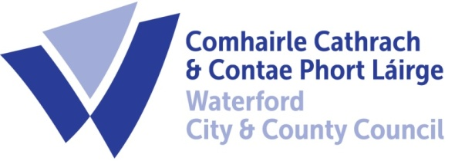

22nd February 2024

To Each Member of the SPC for Environment, Biodiversity and Climate Action

A Chara,

A meeting of the above Strategic Policy Committee (S.P.C.) will be held on Tuesday, 27th February 2024 at 2:30 p.m. in the Conference Room, Dungarvan. You are requested to attend.

AGENDA

- Draft Minutes of meeting held on 27th November 2023. (Attached)
- Matters arising.
- Noise Byelaws Consultation - Niall Kane
- Climate Action Plan – Next Steps - Grainne Kennedy
- Community Climate Action Fund Update – Susan Lee
- CCTV for Waste Management and Litter code of practice – Niall Kane
- A.O.B.
- Date of Next Meeting – 24th September 2024

Fergus Galvin, Director of Services,
Roads, Water & Environment

