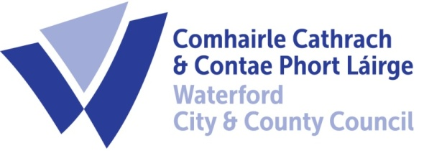

17th October, 2022.
To Each Member of the SPC for Housing, Community, Libraries & Culture

A Chara,

A meeting of the above Strategic Policy Committee (S.P.C.) will be held on the 20the October, 2022 at 9.30am and will be online. You are requested to attend.

AGENDA

- Minutes of last meeting held on the 21st July, 2022 for approval. (Attached)

- Matters arising.

- Creative Ireland Strategy – Katherine Collins presentation.

- Feedback from Subgroups:-

- Affordable Housing
- Choice Based Letting Review
- Vacant Buildings
- Gaeltacht Area
- HDSG report to SPC (Housing Disability Steering Group)
- ASB Strategy review group

- A.O.B.
The PPN have 3 issues for the agenda as follows:
- Call for agenda items and draft agenda and minutes need to issue at least one week (preferably 2) in advance of meetings: reason: to enable representatives to consult their constituents and also to discuss with each other;

- Update on Ukrainian accommodation and other services including community supports.

- Agreed date of next meeting:

Chair : Cllr Eamon Quinlan
Director of Services: Ivan Grimes
Housing, Community, Culture, and Library’s.

