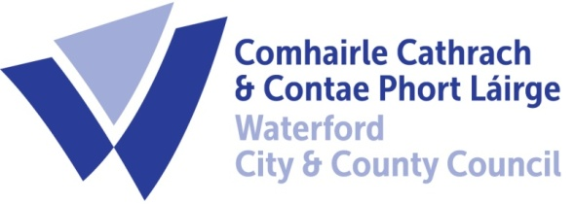

To Each Member of the SPC for Housing, Community, Libraries & Culture

A Chara,

A meeting of the above Strategic Policy Committee (S.P.C.) will be held on the 21st July, 2022 at 9.30am and will be online. You are requested to attend.

AGENDA

- Minutes of last meeting held on the 21st of April, 2022 for approval. (Attached)

- Matters arising/updated:

- Update on Ukrainian accommodation and other services including community supports.
- Housing Delivery action Plan (attached)
- Community Safety Partnership update

- Feedback from Subgroups as available

- Proposal and motions referred to SPC by the Council’s Corporate Policy Group:-

- Motion in the name of Cllr. Cristiona Kiely

“That Waterford City & County Council

- Runs a pilot scheme to set up a Library of Things in a unique location or in a branch of Waterford Library as part of the circular economy, giving people the opportunity to borrow items they only need on an occasional basis such as power tools, camping equipment, roof boxes, gardening equipment, musical instruments, shredders, children’s bicycles, cycling equipment and other items they might otherwise have to buy. This would operate on a similar basis to a book library and would reduce costs, reduce waste and free up space in homes while allowing people avail of the items without the need to purchase.

- Runs a pilot scheme to set up a Library of Toys in a unique location or in a branch of Waterford Library as part of the circular economy, giving people the opportunity to borrow toys for babies and children aged 0-6 which has the dual outcome of making quality toys available to all families while reducing the wastage around the purchase of toys which have a short lifespan. This would bring environmental benefits as toys would be recycled and reused many times, minimising the use of plastic and synthetic materials. It would operate on a similar basis to a book library.

- Runs a public information campaign around the social and environmental benefits of a Library of Things and a Toy Library; encouraging donations of things and toys; promoting the benefits to all sectors of society of using the libraries and highlighting the links to decarbonisation in line with Waterford City & County Council’s intention to become a decarbonised city by 2040. ”.

Reg. No. 206 (dated, 10th November, 2021)

- Motion in the name of Cllr. Cristíona Kiely

“That Waterford City & Council agrees to not commit public funds to organisations involved in bloodsports with the City and County.”

Reg. No. 213 (dated17th April, 2022 )

- A.O.B.

- Agree date of next meeting:-

Chair : Cllr Eamon Quinlan
Director of Services: Ivan Grimes
Housing, Community, Culture, and Library’s.

