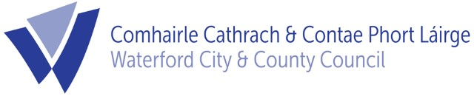
11th July, 2022

To: Each Member of the Planning SPC

The next meeting of the Planning Strategic Policy Committee will take place on Wednesday 13th July at 11.00am. The meeting will take place in the Conference Room, Civic Offices, Dungarvan.

The agenda for this meeting will be as follows -

AGENDA

- Minutes of SPC Meeting of 10th March, 2022

- Development Plan Update

- Taking in Charge & Management of Holiday Home Schemes

- Work Planning for the SPC & Planning Policy Section

- Any Other Business.

Can you please confirm your attendance at this meeting by phone at 051-849957 or by email to cmurphy@waterfordcouncil.ie by 12 noon Tuesday 12th July 2022.

Kieran Kehoe
Director of Services,
Corporate Services, Culture & Planning.

