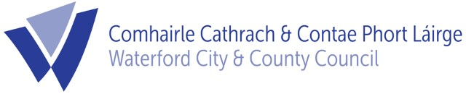
, 2022

To: Each Member of the Planning SPC

The next meeting of the Planning Strategic Policy Committee will take place on Friday 14th October at 10.30am. The meeting will take place using MS Teams.

The agenda for this meeting will be as follows -

AGENDA

- Minutes of SPC Meeting of 13th July, 2022
- Development Contribution Scheme 2022 - 2028
- Any Other Business.

Can you please confirm your attendance at this meeting by phone at 051-849957 or by email to cmurphy@waterfordcouncil.ie by 12 noon Wednesday 12th October, 2022.

Kieran Kehoe
Director of Services,
Corporate Services, Culture & Planning.

