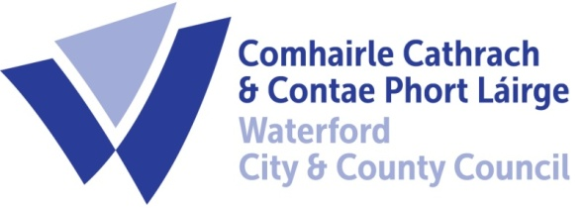

6th December 2023

To Each Member of the SPC for Economic Development & Enterprise

A Chara,

A meeting of the above Strategic Policy Committee (S.P.C.) will be held on Wednesday 13th December at 11.00am @ The Port of Waterford, Gorteens, Waterford. X91 W0XW. You are requested to attend.

AGENDA

- Minutes of last meeting 18th September 2023 for approval.
- Matters arising
- LECP Update
- Local Enterprise Office Update
- Port of Waterford Presentation – David Sinnott, Port of Waterford – CEO
- AOB
- Next Meeting Wednesday February 21st 2024 @ 9.30am - WCCC, Dungarvan Civic Offices, Co. Waterford

*Please note following the meeting there will be a tour of The Port.

Chair,
Cllr. Pat Nugent

Michael Quinn,
Director of Services, Economic Development

