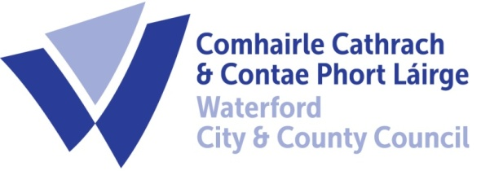

13th February 2023

To Each Member of the SPC for Economic Development & Enterprise

A Chara,

A meeting of the above Strategic Policy Committee (S.P.C.) will be held on Wednesday 22nd February at 9.30 am in The Conference Room, Civic Offices Dungarvan. You are requested to attend.

AGENDA

- Minutes of last meeting 14th December 2022 for approval.
- Matters arising
- South East Economic Monitor Presentation.
- Casual Trading Review
- Waterford 2040 update
- Update on LECP
- Next Meeting 31st May 2023
- A.O.B.

Chair Cllr Pat Nugent
Michael Quinn, Director of Services,
Economic Development

