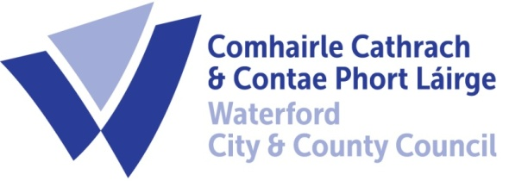

18th September 2023

To Each Member of the SPC for Economic Development & Enterprise

A Chara,

A meeting of the above Strategic Policy Committee (S.P.C.) will be held on Wednesday 27th at 9.30 am in The Conference Room Civic Offices Dungarvan. You are requested to attend.

AGENDA

- Minutes of last meeting 31st May 2023 for approval.
- Matters arising
- Local Development Strategy Presentation
- FI Destination Experience Development Plan
- Street furniture / Outdoor dining furniture proposal
- Next Meeting 13th December 2023 at Port of Waterford
- A.O.B.

Chair
Michael Quinn, Director of Services,
Economic Development

