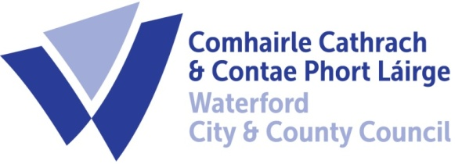

22nd May 2023

To Each Member of the SPC for Economic Development & Enterprise

A Chara,

A meeting of the above Strategic Policy Committee (S.P.C.) will be held on Wednesday 31st May at 9.30 am in The Committee Room, City Hall, The Mall, Waterford. You are requested to attend.

AGENDA

- Minutes of last meeting 22nd February 2023 for approval.
- Matters arising
- Rural Economic Development
- Draft LECP Presentation
- Potential Site Visits
- Next Meeting 27th September 2023
- A.O.B.

Chair Cllr Pat Nugent
Michael Quinn, Director of Services,
Economic Development

