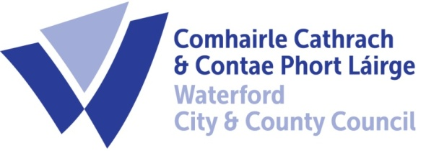

4th October 2023

To Each Member of the SPC for Environment, Climate Action and Biodiversity

A Chara,

A meeting of the above Strategic Policy Committee (S.P.C.) will be held on Tuesday, 10th October 2023 at 3:30 p.m. and will be online via Zoom. You are requested to attend.

AGENDA

- Draft Climate Action Plan (pre Design) (Attached)

Fergus Galvin, Director of Services,
Roads, Water & Environment

