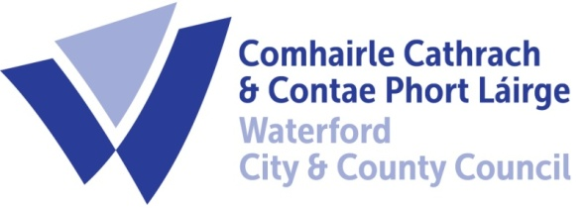

5th September 2023

To Each Member of the SPC for Environment, Climate Action and Biodiversity

A Chara,

A meeting of the above Strategic Policy Committee (S.P.C.) will be held on Tuesday, 12th September 2023 at 2:30 p.m. in the Maritana Room, Menapia Building, Waterford City. You are requested to attend.

AGENDA

- Minutes of meeting held on 9th May 2023. (Attached)
- Matters arising.
- Climate Action Plan Update : Grainne Kennedy
- Noise Byelaws : Niall Kane
- National food recycling week presentation : Dawn Wallace
- Date of Next Meeting – 27th November 2023
- A.O.B.

Fergus Galvin, Director of Services,
Roads, Water & Environment

