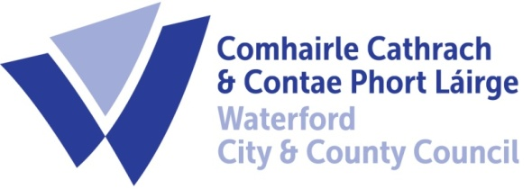

20th November 2023

To Each Member of the SPC for Environment, Climate Action and Biodiversity

A Chara,

A meeting of the above Strategic Policy Committee (S.P.C.) will be held on Monday, 27th November 2023 at 2:30 p.m. and will be online via Teams. You are requested to attend.

AGENDA

- Draft Minutes of meeting held on 12th September 2023.
- Draft Minutes of meeting held on 10th October 2023.
- Matters arising.
- RMCEI EPA Report.
- Noise Byelaws consultation update: Niall Kane
- Climate Change Consultation update: Grainne Kennedy
- Notice of Motion from Plenary Meeting: Reduce use of single use plastic posters in future elections (Attached)
- Date of Next Meeting – TBC
- A.O.B.

Fergus Galvin, Director of Services,
Roads, Water & Environment

